**Blockchain Internet of Things (bIoT): A review of blockchain healthcare security technologies and it’s applications and market opportunities**

**Abstract:** Blockchain has a variety of inherent characteristics, including distributed ledger, decentralized storage, authentication, security, and immutability, and has moved beyond the realm of hype to find practical applications in industries such as healthcare. Due to stringent legal requirements, such as the Health Insurance Portability and Accountability Act of 1996, blockchain applications in the healthcare industry require a higher level of authentication, interoperability, and record sharing (HIPAA). The Internet of Things has diverse applications in nearly every industry, including Smart Health, Smart Transportation, and Smart Cities, etc. In healthcare applications, the Internet of Things facilitates communication between doctors and patients by allowing the latter to be remotely diagnosed in emergency situations via body sensor networks and wearable sensors. In addition, this analysis reveals the market opportunity that will boost the growth of the IoT healthcare market. To conduct the survey, we used specific keywords to search established journal and conference databases for scholarly works. We utilized a filtering mechanism to collect only relevant papers for our research. The selected papers were then carefully examined to determine their contributions and research foci. Ultimately, the paper reviews were analyzed to identify any existing research gaps and unexplored areas of study, as well as to identify potential features for the sustainable development of IoT healthcare.

**Introduction:** Numerous health facility providers, including pharmacies, healthcare facilities, and hospitals, are outfitted with a variety of resources [72]. Information and Communication Technology has facilitated the connection of many physical devices with wearable sensors (ICT).

Whether there is a doctor, researcher, entrepreneur, administrator, or CEO, this have undoubtedly heard of the phrase "blockchain." Blockchain is a new digital architecture based on an immutable distributed ledger that has the potential to improve health record security, validity, auditability, and administration. It has been dubbed a game-changer in the IT sector, but whether it really is remains to be seen. Understanding the potential of blockchain in healthcare requires first knowing about its underlying technological foundations. Unlike conventional centralized databases, blockchain data may be dispersed among several databases/computers (also known as 'nodes'), with the purpose of guaranteeing that all parties engaged in a transaction have access to the same, exact copy of the ledger. Data "blocks" may be linked together to create a "chain" of data that contains the whole transaction history and prohibits any revisions to the original data by employing a hash (a digital signature made up of random letters and numbers) [73, 74]. Because blockchain data is also protected by encryption, participants may have confidence that data 'blocks' are verified and verifiable [73]. (Advanced cryptography) Decentralized data systems are developed as a result of these technical elements (no central authority to be compromised or functioning as a single point of failure), a single source of information for all participants, and fundamentally greater levels of trust (as transactions are immutable, secure, and subject to consensus of the participants). Permissioned blockchains may restrict who may join the network and who has access to the data stored on the network [75].

The electronic devices and software employed for this purpose facilitate the generation, processing, and collection of massive amounts of data. Despite the availability of numerous health care facilities, fatal illnesses such as pneumonia, influenza, cancer, and heart disease have increased significantly [2]. For continuous monitoring and observation of vital signs, sensing devices that can collect, process, and analyze patient information have been implemented as a result of the technological revolution. This information is shared with hospitals and other relevant departments to facilitate the delivery of healthcare services. Legal interoperability concerns are an issue in this scenario. The centralization of the system for medical data management and sharing will increase the efficacy of healthcare delivery [3].

The technology and architecture platform Blockchain was introduced in 2009 [4]. Blockchain functions by storing data in distributed, decentralized recording ledgers across all computing devices that are part of the blockchain infrastructure [4]. The infrastructure is peer-to-peer and functions through network users who participate in transactions and blockchain miners who facilitate transactions in a distributed ledger. The ledger is stored in a decentralized network of nodes generated by cryptographic processes computed by all network miners [5]. Using consensus mechanisms, digital signatures, and hash chains, the blockchain ledger also provides highly dependable storage capabilities [5]. Due to these advanced characteristics, Blockchain provides a variety of services, including traceability, integrity, security, and non-repudiation, while storing all information in a public, decentralized manner and maintaining privacy [5].

In IoT architecture, proper IoT initialization is performed at the physical level to prevent unauthorized access to the system. IoT architecture consists of five layers: Perception, Network, Middleware, Application, and Business. Each layer has its own security objective, with confidentiality, integrity, and availability is the most important in IoT. (CIA) [74]. On the basis of vulnerabilities, IoT attacks fall into four categories: "Physical attack," "Software attack," "Network attack," and "Encryption attack."

Health blockchains are being researched for a wide range of applications, including healthcare data management and interoperability (such as patient healthcare, consumer health, and hospital data), enhancing the integrity of published research, clinical trial management, use and integration into IoMT applications (such as mHealth and remote patient monitoring), advancing genomics and precision medicine, and biomedical and mHealth applications. Because many health-related blockchain efforts are released in white papers, news articles, press releases, presented at conferences, or otherwise exposed while being developed for commercialization purposes, the existing literature merely provides a glimpse of global blockchain activity. According to the World Economic Forum, by 2025, 10% of global GDP will be kept on blockchain technology [76], and several big technology corporations, including IBM, Intel, and Microsoft, have made significant investments in blockchain technology research. While blockchain technology has the potential to transform the healthcare business, it is still in its early stages. Currently, the healthcare and life sciences sectors are in phases one and two of Gartner's 'hype cycle' for blockchain technology [77]. This cycle includes innovative triggers, inflated expectations, disappointment, enlightenment, and a "productive plateau." Real-world blockchain systems with substantial commercial or user acceptance in healthcare are still rare, owing to the fact that health blockchains are still in their early stages. The firm's financial technology services and supply chain and logistics divisions have been significantly faster users of technology. A plan is required to ensure that blockchain technology is "fit-for-purpose" for specific and diverse healthcare challenges, despite the apparent benefits of decentralization, security, provenance, transparency, trust, and improved data management in meeting urgent healthcare needs. When evaluating the practicality of a blockchain for healthcare, what basic blockchain features and design principles must be considered, and how can they handle the particular legal, regulatory, privacy, business, provider-centric, and patient-centric considerations? This Forum post proposes a 'fit-for-purpose' health blockchain design framework that aims to address these challenges by resolving basic issues concerning blockchain design principles, data sharing and management, governance choices, and other topics. It also dives into the technologies that may enhance blockchain functioning and specifies the blockchain solution's final aim. If the aforementioned questions can be accurately mapped, there is a larger chance that the blockchain technique will be "fit-for-purpose" for the given healthcare issue.

In IoT architecture, proper initialization of IoT is done at the physical level so that any unauthorized receiver cannot access the system. IoT architecture consists of five layers: the Perception layer, Network layer, Middleware Layer, Application layer, and Business layer. Each layer has its objective and issues main security goals crucial in IoT are Confidentiality, Integrity, and Availability (CIA). Based on vulnerabilities, there are four categories of attacks in IoT: “Physical attack,” “Software attack,” Network attack,” and “Encryption attack.”

**The ultimate use of blockchain in the healthcare system:** While it seems evident that blockchain technology will have a beneficial influence on the healthcare business, explaining this impact remains a substantial difficulty. In addition to the overall benefits of a distributed, irreversible, transparent, and higher-trust system, the exact advantages of a blockchain system over other current technologies for healthcare operations must be evaluated. Each blockchain network's objective will be different. Some may simply seek to reduce administrative costs and other fees connected with healthcare transactions via strategies such as smart contracting and other types of process optimization and automation. Some individuals may be obsessed with constructing money-making devices. Some will use incentives to encourage improved data collection, utilization, and sharing from patients, customers, and providers. Some individuals may be more interested in the indirect advantages, such as enhanced compliance or reduced fraud. While originally developed for the most practical applications, various blockchains may be designed to achieve a variety of objectives.

The sixth factor to address is if a blockchain is really required to solve the healthcare problem or achieve the objective at hand. The ideas for a "fit-for-purpose" blockchain architecture outlined above are not comprehensive, but they give a framework for thinking about how blockchains may be constructed to better healthcare and, ultimately, patient outcomes. The goal of this article is to use this architecture as a springboard to study the possible future state of a "health" blockchain by evaluating a number of critical healthcare use cases. The purpose of this paper is to examine several points of view on the key design features, challenges, possibilities, and best practices of the future health blockchain ecosystem. The purpose of this article is to bring together a diverse group of professionals from academia, the private sector, healthcare startups, and professional technology associations to discuss use cases in healthcare records, clinical trial management, medical credentialing and licensing, genomics and precision medicine, the pharmaceutical supply chain, and biomedical research. Finally, the story concludes with an IEEE Standards Association discussion on the need of creating technical and industrial standards to guarantee blockchain in healthcare delivers on its revolutionary promise in 21st century healthcare.

**Integrating private prediction algorithms and blockchain technology with E-Health records:**

One of the most critical applications for blockchain is in healthcare record keeping. [78, 79, 80, 81]. The purpose of blockchain-based healthcare record management is to enable the secure movement of patient information between parties while protecting its integrity, validity, and, in many situations, confidentiality [80, 82-83]. If it is observed regarding the impact of privacy preserve prediction model, it is clearly notified which is often used characteristics of block chain technology in the recording regarding Healthcare Application [84-85]. Hospitals and other healthcare institutions may use machine learning models trained on data from their electronic health record (EHR) systems to assume the condition of disease holder or the situation. When dealing with uncommon conditions/diseases, for example, a single hospital or institution may not have enough patient records to develop a generalizable model from its own EHR data. Increasing the number of records maintained by hospitals and other organizations seems to be a natural first step toward addressing this issue. However, there are certain privacy concerns with this strategy, such as re-identification [86] and data breaches [87]. Thus, numerous assumption model has been developed temporarily to help to build an accurate predictive model which can regain bottleneck problem [88,89]. In this way, all the institution can build a model by combining block chain and temporarily prepared model without leaking the confidentiality of patient data. Participants in cross-institutional model learning are the users of this blockchain-based method to issue solving. All user-submitted data must be in the same format and have the same semantic meaning to maintain consistency with patient-level data in the EHR. Importantly, only predictive models derived from EHR data are transmitted between hospitals/institutions through the blockchain network; no direct data is transferred. This blockchain network's peers are the same as its users. In this use example, peers "verify" the data by wrapping their incomplete models in to build blocks, receiving the data from other peers, verifying the data update the assumption with the data of EHR. This process is described as a learning process which occurs "online," as the name indicates, with the model being progressively updated with just incomplete input. In addition, training errors are utilized to rank online learning on the blockchain, with the expectation that sources with greater error rates would contribute more data to enhance the model. This iterative learning process continues until all participants agree on a model for generating predictions. As a consequence, blockchain offers significant advantages for issue solving, such as the capacity to maintain anonymity by sharing only relevant models, removing single points of errors, and provide unchangeable records for the aforementioned process. According to the concept about "purpose-fit" blockchain design features, blockchain-based privacy-preserving learning design is private. While models and meta-information about those models may be shared on-chain, off-chain data transfer is not yet allowed. According to the law, only who take part in it will only be involved in the blockchain network, and updated models is what drives these users/peers to engage by offering fresh insights into patient and population health outcomes. This blockchain-based healthcare information management learning system's ultimate purpose is to enhance patient care, biological research, and comparative effectiveness studies.

**Blockchain architecture variants:** Determine whether the blockchain will be public or private or a hybrid of the two. Numerous privacy, legal, and regulatory constraints (including HIPAA and the General Data Protection Regulation) restrict how easily healthcare institutions may exchange and get patient information. Permission structures, data types to be communicated between participants, whether data will be kept on-chain, off-chain, or on a side-chain, and other similar decisions must be determined.

It is required to make decisions on governance, which is an essential component of the overall architecture of the blockchain system. It must be indicated if the blockchain will only include trusted partners, a consortium of participants, government agencies or regulators, and patients/consumers/the general public as nodes, users, peers, and/or validators. Finally, the mechanism through which these institutions will make administrative decisions concerning blockchain technology must be described.

It is already demonstrated, the blockchain architecture can facilitate the integration of cryptocurrency/tokens which will be beneficial to all participants, automation using smart contact processes, and the development of an application layer that interfaces with the blockchain.

**Related Works:** He and colleagues devised anonymous authentication with shown security for the WBAN. Tawalbeh and colleagues [17]. The role and capabilities of mobile cloud computing and big data analysis in networked healthcare were investigated. The applications of big data analytics in healthcare, methodology and tools are examined by this article. Ha and Hong [26] provided an overview of augmented reality (AR). They examined contemporary pharmaceutical uses. After discussing the fundamental idea, concise characteristics of the three AR-related parts (hardware, software, and application) are provided. The authors evaluate numerous laboratory applications. Sreekanth and Nithya [54] studied healthcare system applications, ideas, and current technology. They underlined the distinctions between these strategies and provided a concise explanation about tailored IoT healthcare. They concentrated mostly on ubiquitous wearable devices that capture different patient-specific data. Khan [8] suggested and constructed an efficient healthcare monitoring system (HCMS) using IoT and RFID tags. This article's findings demonstrate the effectiveness against many medical crises. A mix of microcontrollers and sensors is employed in the proposed system to consideration evaluation results, track and measure the patient ’s progress, and expand the IoT's capabilities. Baker et al. [15] performed comprehensive research that examined the benefits, drawbacks, and general applicability of the wearing body sensor network (BSN) in the IoT healthcare system. Safety, confidentiality, hygiene, and reduced intake, as well as research proposals for the future are focused on paper. Minoli et al. [71] provided an OSiRM-based network framework and examined IoT deployment-related security tools and methodologies. These safeguards are particularly vital for e-health and assisted living. Blythe and Johnson [6] centered their development efforts on the CSI technique. When assessing the importance, attractiveness, or potential engagement of a security label, a team of IoT security professionals examines the desired security aspects. Oueida et al. [10] proposed an RPN architecture based on Pedi Net that blends edges and cloud technologies and is appropriate for emergency department systems (EDs). The RPN can relevant in actual conditions where critical performance metrics such as patient length of stay (LoS), patient health status, and treatment wait times are shaped and improved. A paradigm for an intelligent medicine box (iMedBox) was suggested by Srinivas et al. [33] The enabled devices alert sufferers to their medicine at the right moment and provide feedback via Android smartphone notifications. Pallavi and Tripti [31] presented an HCMS for troops based on IoT. Using the GPS tracker, the suggested system can monitor the troops and their present position. Moreover, it helps to safeguard cloud data using cryptographic techniques. Ngankam et al. suggested the creation of an ambient assisted living (AAL) system for smart cities. [70] In the laboratory, the suggested architecture, which is based on a microservices system, has been tested and assessed. Dwivedi et al. [63] suggested a fresh framework for IoT-compatible blockchain models with modifications. Using the blockchain, the framework attempts to resolve healthcare issues. Using the technology, data transmission across a blockchain-based network is more secure. Sharma et al. [34] presented a concept of intelligent collaborative security to mitigate security concerns. They assessed Internet - of - things safety and confidentiality, in addition to other aspects of medical care security demands, vulnerability assessments, and classifications. Those named Kadhim et al. [65] provided the fundamental overview of the pros and limitations of the Internet-based HCMS. They debated the use and constraints of IoT healthcare so a bid to establish boundaries in various health sectors and enhance healthcare quality. Lemlouma et al. [66] developed for e-health solutions a framework for the intelligent and autonomous assessment of geriatric dependence. The usefulness of such frameworks is found in effective and efficient health solutions deployed in a smart dwelling or smart town scenario, where quick assistance may be offered if someone is in danger. The most essential problems about how to leverage the benefits of context and characterization modeling were addressed by mHealth services and applications. Under the pressing circumstances of sensible condition monitoring for the elderly, mHealth becomes a more difficult subject. Bouletafes et al. [67] offered a method for developing and evaluating situationally accessibility healthcare tracking systems. The framework was theoretically validated, however they requested additional simulation-based validation. Lemlouma et al. [68] created a methodology for integrating e-Health services into the IP multimedia subsystem (IMS) to ensure that the facility is informed of something like a patient's status. The adaptable paradigm does not represent a core tech, instead it is an improvement to the current IMS, making it more flexible and easier for connect to existing e-Health services. Internet - of - things healthcare apps and gadgets, surpassing the present healthcare system's incapacity to collect specialized data, authentic accessibility, advanced analytics via web service, and so on [1], as well as lessening complexity and obstacles. To encourage and promote a better lifestyle, effective m-health and e-health apps are deployed. [62] Table I provides a brief comparison of healthcare technology between 2016 and 2020. In this research, we investigated a variety of scientific articles on IoT and healthcare and compared the methodology utilized in these publications.

|  |  |  |  |
| --- | --- | --- | --- |
| Year/References | Methodologies | Merits | Limitations |
| 2016  [17],[26],[54] | * Cloud computing in mobile based system, * Big Data * Augmented Reality * Wearable Devices | * Data can be store and use properly * Enhances the perception and entertains patients * Patient alert system and wrist-worn device monitoring. | * Requires a lot of memory * Costly to develop AR enabled devices * Not all wearables are standalone |
| 2017  [8],[15],[122] | * Monitoring system using RFID * Body sensor networks * Open Systems IoT Reference Security Model (OSIRM) | * Monitoring patients’ health history in hospitals * WSNs Enable Long-distance Data Collection and Transmission * Differentiates activities, terminals, and ports precisely. | * Expensive because due to use of batteries * Vulnerable to malicious security attacks * Provides service duplication over many tiers |
| 2018  [6],[10],[33] | * Index of Consumer Security (CSI) * Resource Preservation Net (RPN) framework using Pedi Net * Intelligent medicine box | * Improve consumer decision and security provision * Average patient waiting time are optimized. * Notifies patients about the medication at the appropriate time | * Takes more time to implement * Requires a lot of storage * Drug dispensing machines may be programmed incorrectly |
| 2019  [31],[120],[63] | * Healthcare monitoring system for soldiers * Ambient Assisted Living * Security model of blockchain, Pow | * Tracking solder’s location and secure their cloud data * Get help with daily Activities * Data are extremely resilient to technical breakdowns and harmful assaults. | * The battery might drain out * Costly * Lack of data modification private keys |
| 2020  [64],[65] | * WSN security model * Internet-based Healthcare Monitoring System (HCMS) | * Secures the collected data * Monitoring health history of patients in the hospitals | * Data is stolen while securing data * Hospital management maintenance is very expensive |

**Medical Application Used in the Review:** Reducing ED wait times is a high objective for the vast majority of healthcare systems. A new study provides hospitals with a framework based on large data sets so that they may easily manage difficulties. Using IoT and predictive analytics, the program can identify the usual flow of patients via an emergency department. The technology calculates processing times throughout patient admission and the normal flow of patients through with an emergency department, allowing healthcare system to maintain an appropriate average wait time [55]. According to one research, a New York hospital has partnered with GE to install IoT-based sensors on emergency rooms that would display if a bed is unoccupied or occupied [56]. In a [2] WSN MEDiSN, physiological monitors (PMs) provide medically relevant information to track patients' biomedical signals during catastrophe situations and the crisis phase.

2) Telehealth allows individuals of various ages to remotely monitor vital health information and assume control of their own health. Active and real-time participation of patients, hospitals, carers, and physicians is advocated through IoT-based real-time monitoring [30]. In order to limit traffic and avoid messages from being dropped, the suggested system determines the shortest time for message splitting and evaluates the minimum waiting lengths for healthcare personnel nodding. The combination of IoT and telemedicine [59] in CyberMed enables the deployment of patient-specific medical equipment. The recorded information is stored on the cloud for near-instantaneous examination by the physician, assuring wearability and data quality. An IoT-based telemetric system is proposed, which provides telemedicine services to bedridden patients and monitors their health. [61].

3) Information Monitoring: The incorporation of existing medical advances also with Internet of Things (IoT), in addition to interacting with patients and their surroundings, considerably increased the possibilities for data collection and decision-making. It is recommended that IoT devices may be utilized to enhance people's health, as well as to ensure that there are no errors in the process of medication and drug distribution. RFID and IoT are two key innovations for ‘intelligent remote monitoring of patients, with IoT applied for personal information analysis and storage whereas the RFID permits the monitoring of crucial health records. With getting information from tag sites and relaying it to the IoT cloud, critical analysis is conceivable. A technique for acquiring actual patient ’s information that uses ZigBee and GSM wireless technologies. It is discussed how to use ZigBee-based wireless body area sensor network (WBASN) technology to continuously monitor human health and whereabouts. Another research proposes a method comprised of tiny worn biological instruments, sensor systems, and broadcast modules that employ a cryptographic approach to track a trooper's current GPS position but also health status.

4) Medication Management: Drug concordance and adverse reactions to medications (ADRs) were two of the most significant human safety concerns inside the health sector. In addition to polypharmacy, 15% of patients have statistically important effects as a result of drug dosage and distribution plan violations. The study offers movital [32], a novel system for drug recognition and medication tracking based on IoT technology. Wisepill Technologies and Aeris provide IoT-enabled digital pillboxes for treatment plan for their patients [60]. Those who are collaborating to assist biopharmaceutical businesses and health agencies all across the world. The smart residence pharmaceutical container with a broadband system and a Mobile application is shown [33], that also assists sufferers by reminding them when to take their medication and allows physicians and patients to communicate more effectively. In an IoT-based approach [34], the real-time impact of a drug is monitored by mobile or wearable devices, that will also identify any unwanted side effects but also enhance the effectiveness of medical businesses' goods.

5) Food Management: Measurement and automation of food nutritional content is critical in neonatal and adult health development. [35] Smart-Log is a brand-new IoT-based, completely automated nutrition monitoring solution. A unique 5-layer perceptron neural network, an efficient meal forecasting approach that is based on a Bayesian Network, Area network capable devices enabling nutrition and food evaluation, and a cellphone comprise this system. In this study [36], we provide a proper food intake monitoring method that employs vibration signals from such a detector carried on the participant's wrist across a whole meal to calculate food intake. The technology detects peaks and gives additional information on dietary patterns such as total number of chews, bitestoken frequency, and eating tempo to the user. A smart dining table measures the weight of food ingested using a weighing sensor and radio-frequency identification (RFID).

6) Determination of Glucose Level: Diabetes seems to be a group of metabolic disorders characterized by a persistently high glucose level. A steady blood glucose level causes sugar poisoning, that promotes into tissue dysfunction and diabetes sequelae pathology. Regular monitoring of sugar levels swings shows distinct patterns and aids in the management of foods, medications, and behaviors that always impact diabetes care. The utility finding shows a human information serum insulin gathering devices are mainly for an IoT that consists of a sugar levels collector, a smart phone or computer, as well as a back - ground microprocessor. This same Internet - of - things multi - parameter healthcare procurement sensor suggested in [38] layer formation data communication consistency and high accuracy, in addition to the present occurrence of ZigBee wireless networks, Area network wifi devices, based on wireless networks, 3G, 4G wireless networks, and cable networks, which transmit valuable information rapidly and precisely in diverse areas. Furthermore, IPv6 connections connect m-IoT-based noninvasive insulin levels detectors from sufferers to the relevant healthcare professional, and the IEEE 802.15.4-compliant 6LoWPAN offering flexible wirelessly embedded sensors [37].

7) Electrocardiogram (ECG) Monitoring is a revolutionary approach which focuses on the IoT platform Cypress wireless Internet connection for embedded applications (WICEDs). For data sharing and equipment management, IoT makes use of shared by people such as CoAP/HTTP, MQTT, TLS/TCP, DTLS/UDP, and OMALWM2M. In this technique, data is captured by either a remote patient monitoring module and instantly [39] sent to the IoT cloud. Numerous research projects have examined IoT-based ECG monitoring in detail [83],[40],[41]. Realization of a complete ECG signal identification method at the application layer of ECG, inside the IoT technological domain. Depending on the wavelet transform approach, this incorporates a variety of identification techniques, definitions, and threshold settings, and the improved envelope changes the Ecg data and recognizes and determines the exact position and shape of the P and T waves (QRS wave group). Based on MATLAB simulation and MIT-BIH database mark comparison, the identification system has a 0.89 percent erroneous detection accuracy. An Internet of Things-based ECG monitoring system [42] comprised of a wireless wearable detecting microprocessor and a remote procurement broadcaster. The incorporation of a searchable automated test method for the detection of anomalous data allows for real-time diagnosis of heart function.

8) Blood Pressure Monitoring: The bring blood pressure (BP)/pulse rate/blood oxygenation measuring smart position terminal [43] is revealed by the IoT-based utility model. The monitoring equipment measures physical indications in real-time using a blood pressure collection and processing device and a blood oxygen/pulse rate probe. As a data communication device, a subscriber identification module (SIM), a general packet radio service (GPRS) module, and an antenna are compromised. Table VI outlines the IoT healthcare applications, their respective accessing technologies, benefits, and restrictions. Constant remote blood pressure control is necessary in a [44] persuasive situation involving connectivity infrastructure here between health post and a health center. The recipient is an Apple mobile computing device that can communicate with BP equipment [45]. For BP monitoring in IoT-based systems, a stay in touch (KIT) blood pressure (BP) sensor combined with a Near Field Communication and Radio Frequency Identification (NFC)-enabled KIT mobile phone is used [46].

9) Monitoring of Oxygen Saturation: Supplemental oxygen is appropriate for painless, continuous measurement of blood oxygen saturation. For application in WSN-based health monitoring, a worn pulsing oxygen concentrator that could be integrated to the IoT network is proposed [47]. Pulse oximetry and the Internet of Things integration is crucial for technology-driven medical healthcare applications. The deployment of a CoAP-based WSN technique enables the tracking of sensing devices which handle the promise of Internet - of - things pulse oximetry [48]. The sensor and Bluetooth health device profile communicate with the Money platform, which manages device connectivity. A minimal, low-cost IoT-optimized pulse oxygen concentrator is employed for constant monitoring systems of the patient's health [49].

10) Rehabilitation SystemIssues associated with the aging communities and a scarcity of health centers Smart rehabilitation solutions utilizing the Internet of Things are becoming a more prominent approach of addressing this problem. A wireless network-connected IoT-based management system with trained bots, a planner, and sensor is provided to improve the rehabilitation training of hemiplegic patients [50]. Computers in an ontology-based ADM [51] take action based on their comprehension of symptoms and medical resources. BSNs are intensified to build a comprehensive rehabilitative activity as well as augmented reality (AR) environment for stroke patients and healthcare expert interaction [52]. Although there is a large body of research indicating that language training systems for children with autism interact wirelessly with both the supervisory control platform via an IoT-based highly centralised training school [53] and an integrated software scheme for prison systems [54], this has not been confirmed.

|  |  |  |  |  |
| --- | --- | --- | --- | --- |
| Year | Application | Advantages | Limitations | Accessing  Technology |
| 2020 | Dropping  Emergency Room  Waiting Time  [55],[56],[2] | ●Use predictive analytics for flow of patients  ●Monitor physiological data during emergency | ●Scalability needs to be improved. increase energy consumption | ● Special sensors based on IoT, wireless sensor network  ●MEDiSN |
| 2018 | Telehealth  [30],[59],[61] | ●Minimum time for separating messages  ●Ensure wear ability and data quality  ●Track bed-ridden patients | ●Requires a high-quality security module, requires  technical training, server problems can make virtual communication impossible | ●Real-time monitoring, telemetric system.  ●CyberMed |
| 2018 | Tracking of Information  [71],[106],[72],[7] | ●Track patient information  ●Continuous monitor human location | ●Security of information, continuous Internet connections | ●RFID tag  ●ZigBee, and GSM wireless technology  ●Wireless body area networks (WBASNs) sensor |
| 2017 | Drug Management  [32],[60],[33],[34] | ●Drug identification and monitoring of medication  ●10T-enabled smart pillboxes  ●Give alerts for medication | ●Interruption can cause problem | ● Wisepill technologies and Aeris wireless connection |
| 2018 | Food Management  [35],[36] | ●Real-time food intake monitoring system  ●Construct a smart dining table | ●Need cost effective sensor system  ●A Bayesian Network | ●Novel 5-layer perceptron neural network  ●Weighing sensor |
| 2016 | Glucose Level  [37],[80],[38] | ●Ensure the long-distance data transmission's stability and correctness.  ●Keep track of blood glucose | ●Need operator technique, exposure, environmental and patient factors  ●6LoWPAN protocol | ●ZigBee wireless network,  ●Bluetooth radio network  ●IEEE 802.15.4 |
| 2014 | Electrocardiogram  [39],[83],[84],[40], [41],[42] | ●Detect threshold parameters  ●Transform of ECG signal  ●Determine a certain form  ● The P and T wave (QRS) wave group's position. | ●Data stream mining and context awareness technologies  ●MATLAB simulation | ●CoAP/HTTP, MQTT,  ●TLS/TCP, DTLS/UDP |
| 2012 | Blood Pressure (BP)  [43],[44],[45],[46] | ●Real-time BP measurement | ●Continuous Internet connection  ● Keep in Touch (KIT) blood pressure meter  ●RFID | ●NFC stands for Near-Field Communication |
| 2014 | Oxygen Saturation  [47],[48],[49] | ●Monitor blood oxygen saturation | ●Low power/low-cost pulse oximeter  ●Realtime monitoring | ●Wireless Sensor Networks (WSN) wearable pulse oximeter  ●CoAP protocol |
| 2016 | Rehabilitation System  [50],[51],[52],[53],[54] | ●Provide rehabilitation exercise  Rehabilitation training of hemiplegic patients | ●Proper knowledge about training  ●IOT sensors. | ●Body Sensor  ●Networks (BSN) |

**The IoT Module:** This module discusses how to gather data via wearable technology and biomaterials, whether they are worn by patients or those who are present in the setting where patients are observed. To put it another way, a wearable sensor is the ideal way to keep track of the data that a patient generates every single second while getting mild treatment and undergoing medical testing. The patient's wearable may capture the following data: pulse rate, metabolic flow, breathing enhancement, and sleeping phase tracking. Furthermore, if indeed the patient has pacemakers or blood pressure measurement devices implanted, these signals may well be automatically monitored utilizing the Iot. module. There is a high demand for IoT sensors or bio sensors to be placed on patients who are bedridden or have been taken to the hospital. These sensors must be capable of detecting environmental conditions and taking necessary response.

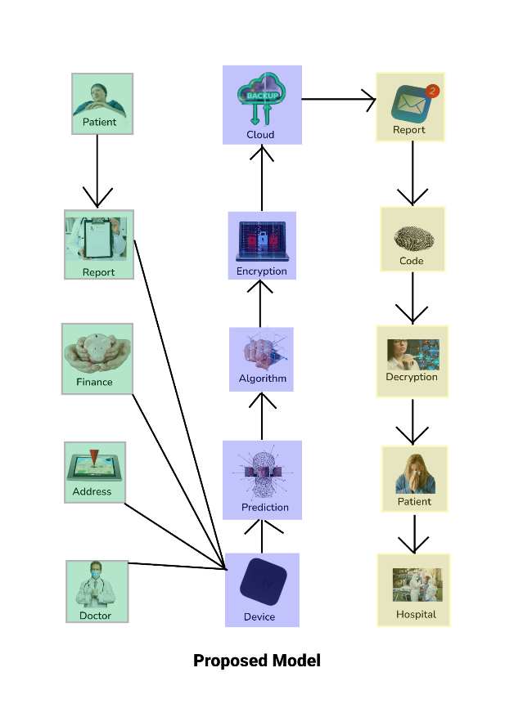

Fig:1: Proposed Model

**Module for Machine Learning:** The Deep Learning Method analyzes the patient's data for abnormalities. Training the model to identify anomalies in the data being gathered may substantially benefit in anomaly detection. When an abnormality is discovered, the doctor is contacted, and based on the circumstances, the necessary course of action may be taken. It also attempts to predict whether or not the patient has a deadly disease. If anything, odd is identified, the report will provide those facts for the physicians to investigate further. Given that the predictions are based on a model, there may be some margin for error that must be considered in this circumstance.

Diabetes Prediction (Naïve Bayes)

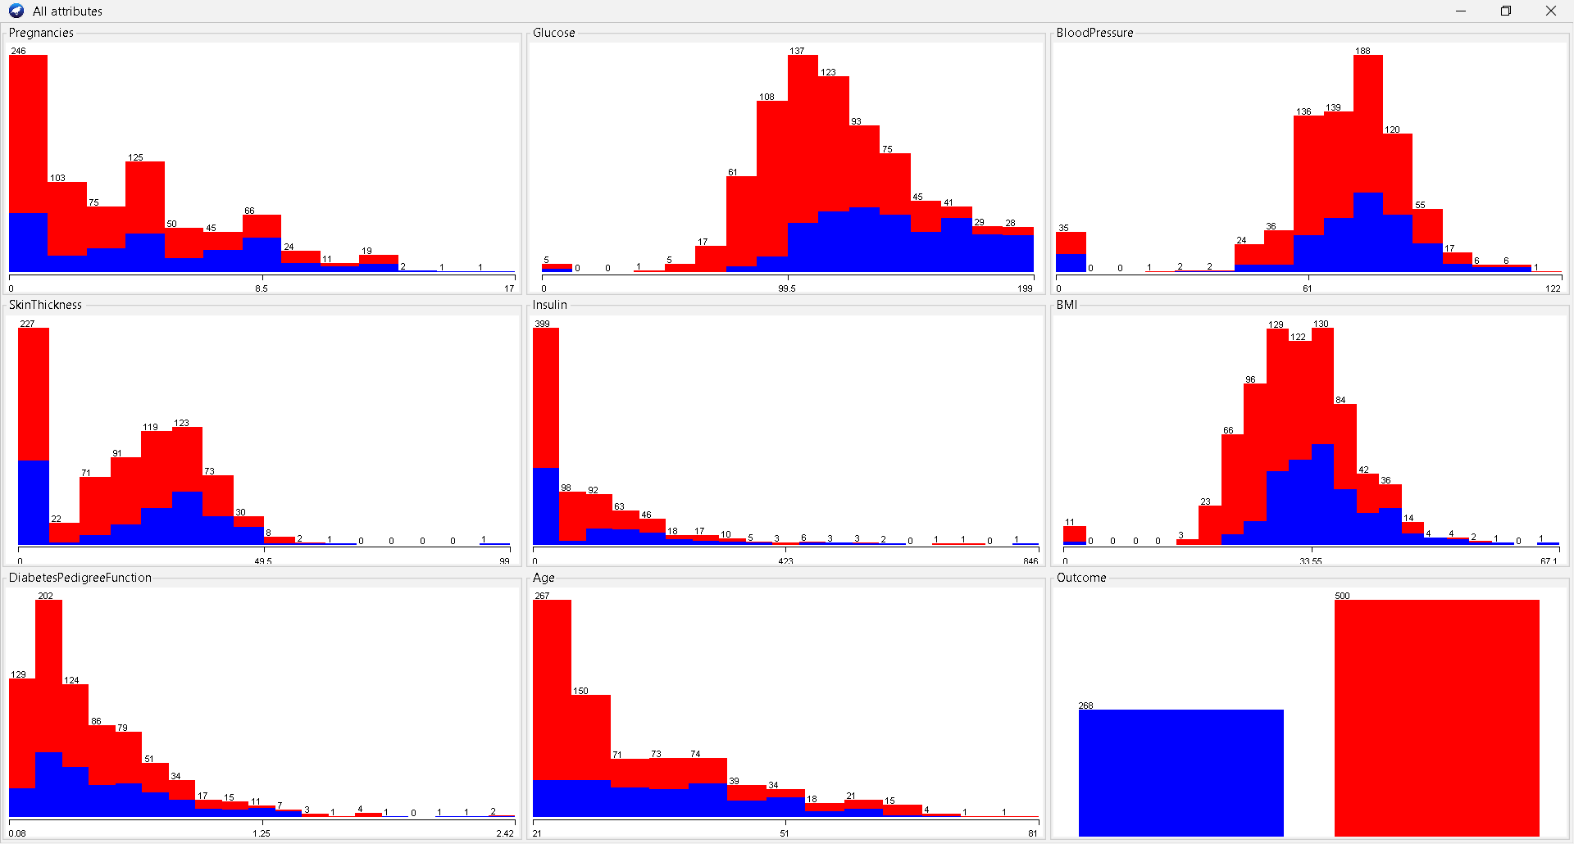

Fig:2: Diabetes Prediction[111]

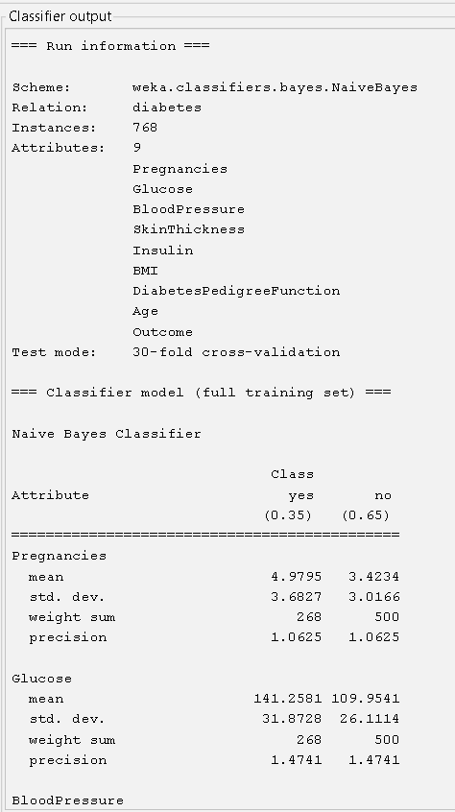

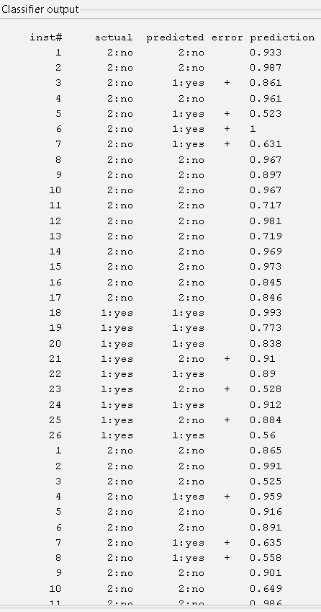

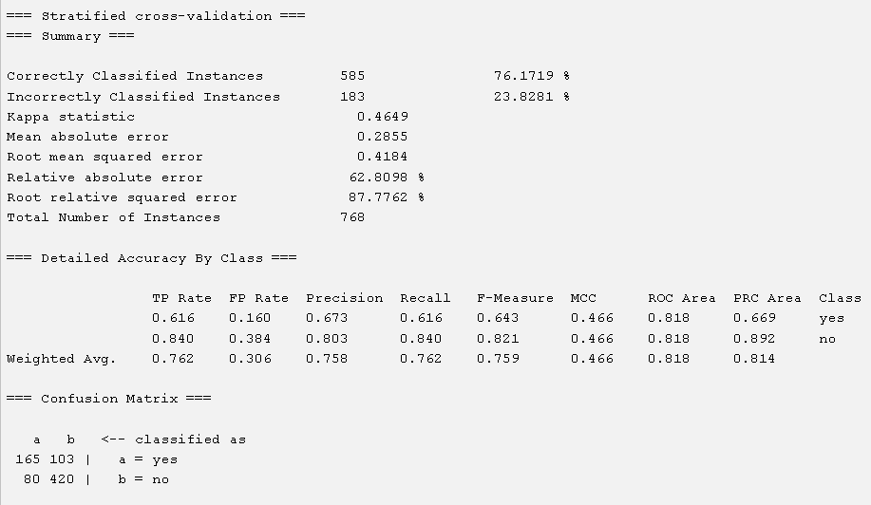

Cancer Patient data set (IBK)

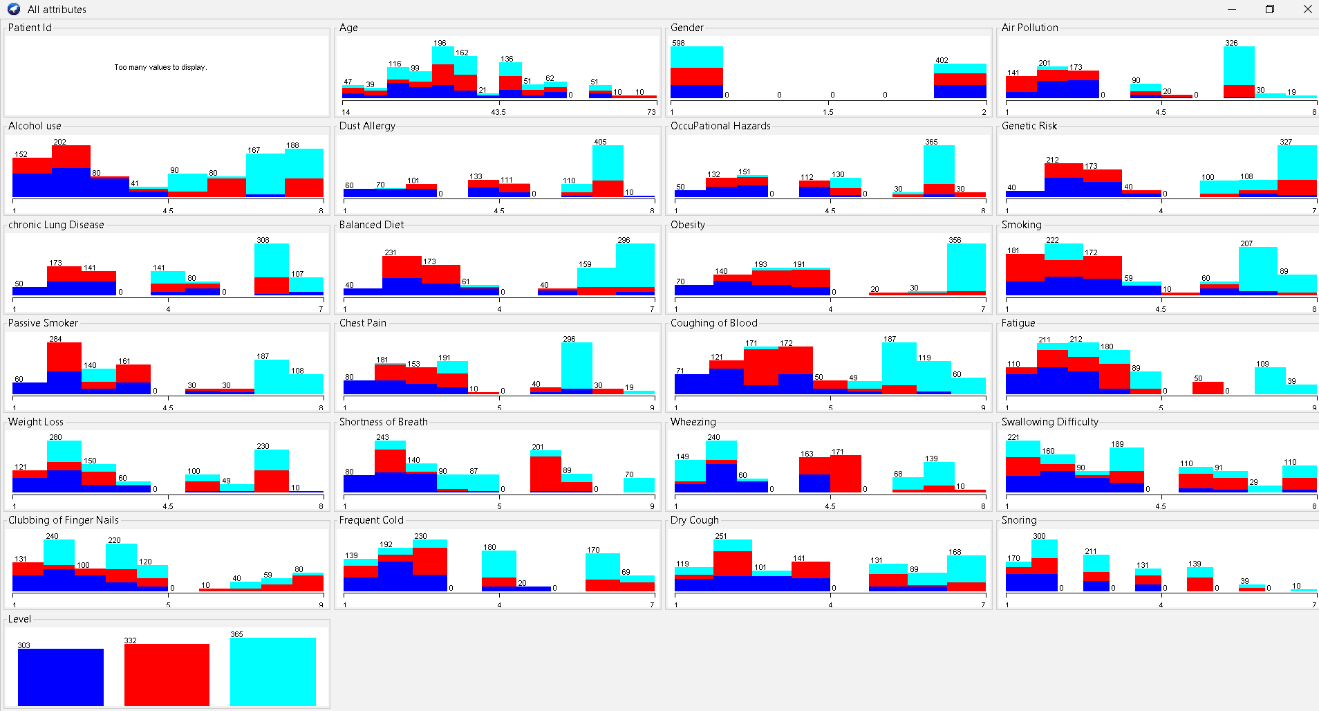

Fig:3: Cancer Patient data set[112]

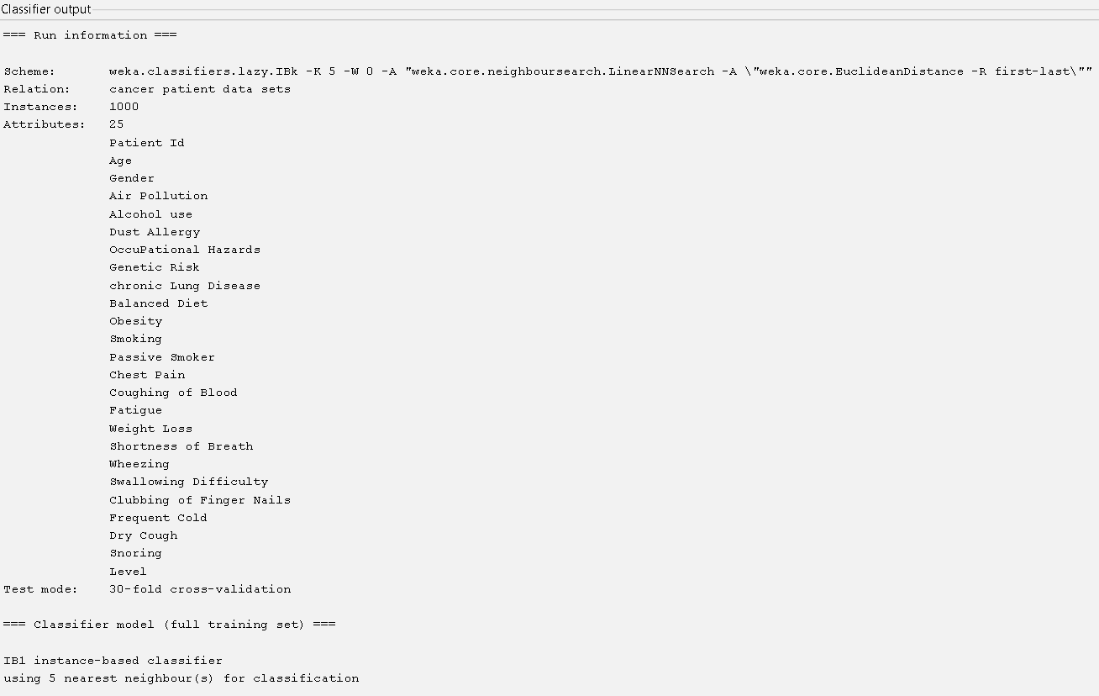

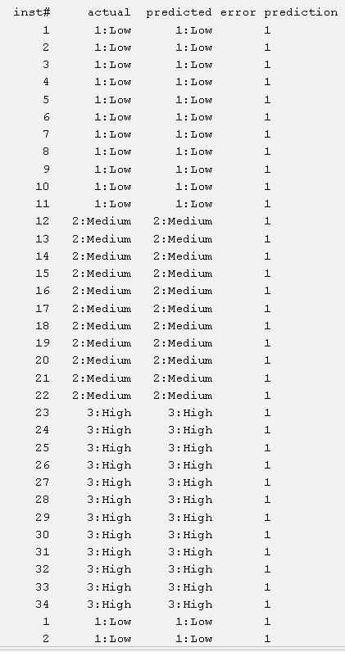

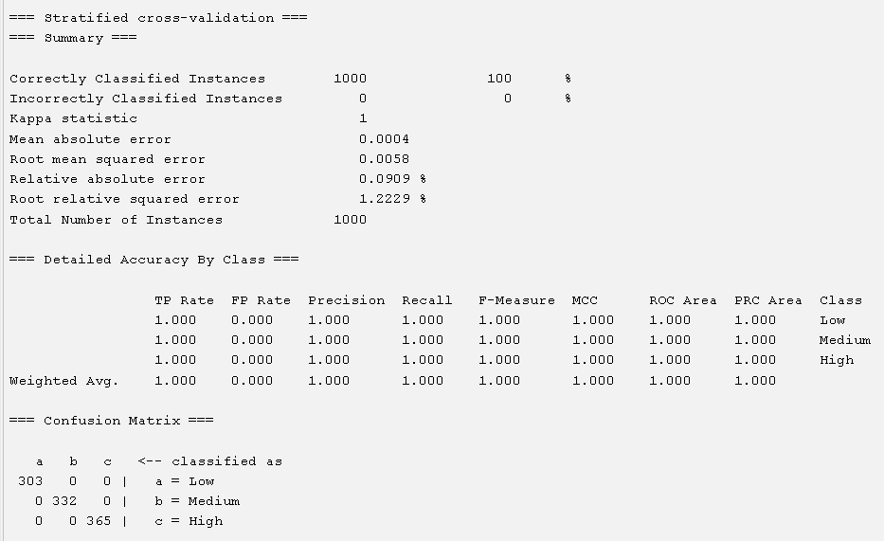

Stroke Prediction (IBK)

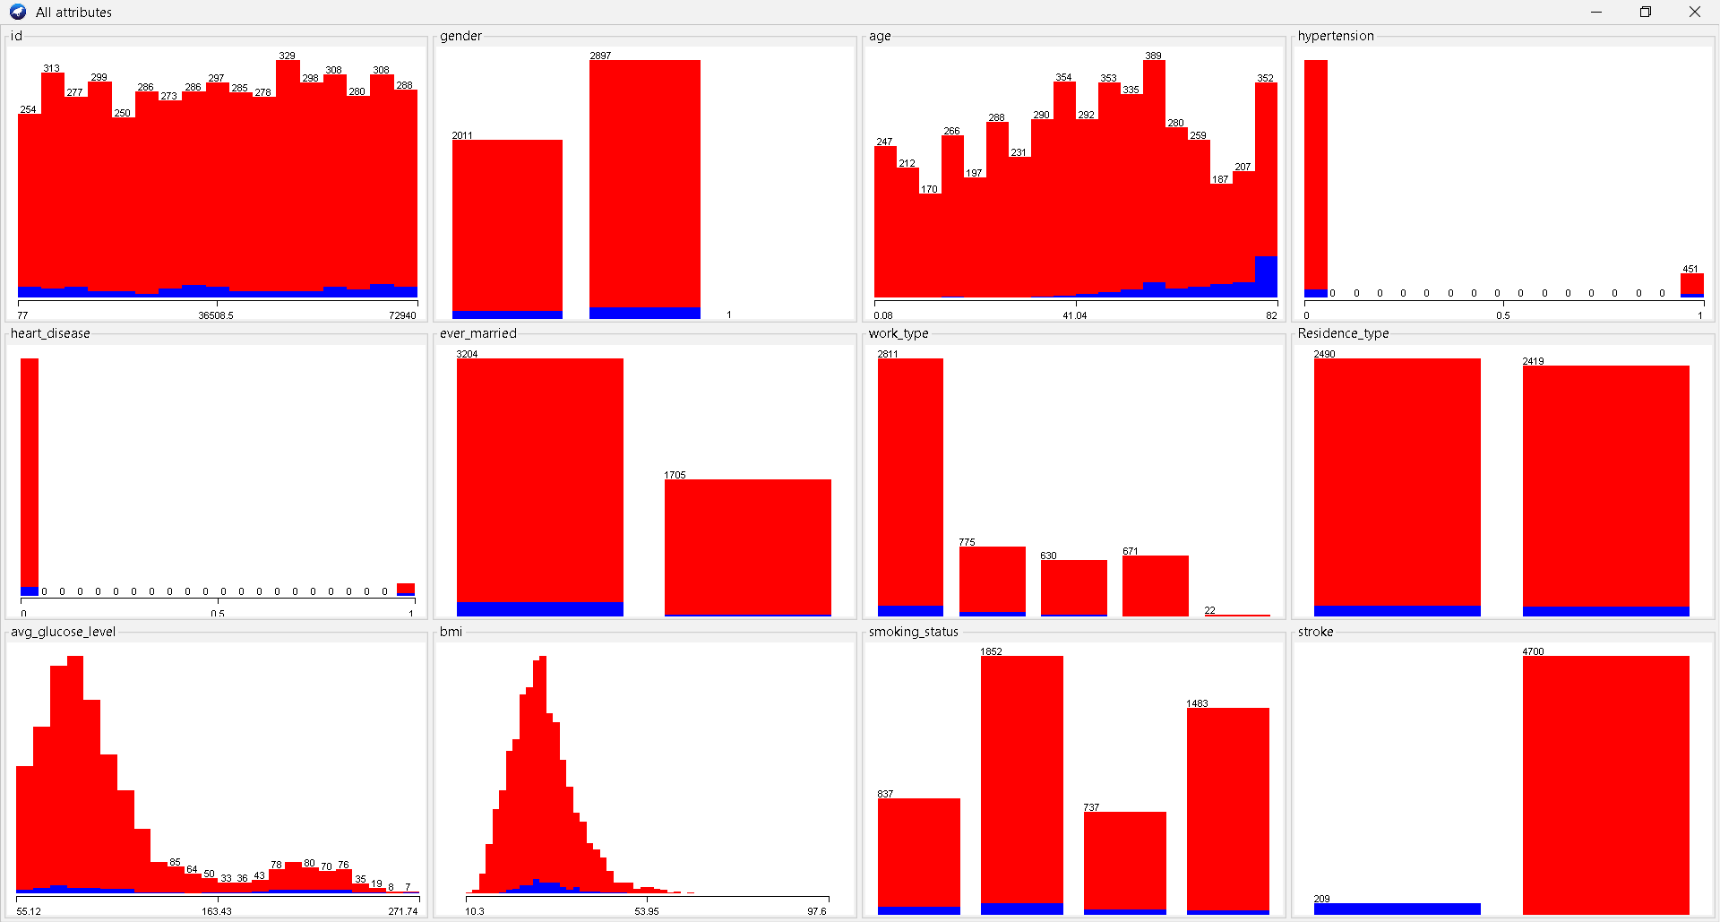

Fig:4: Stroke Prediction[113]

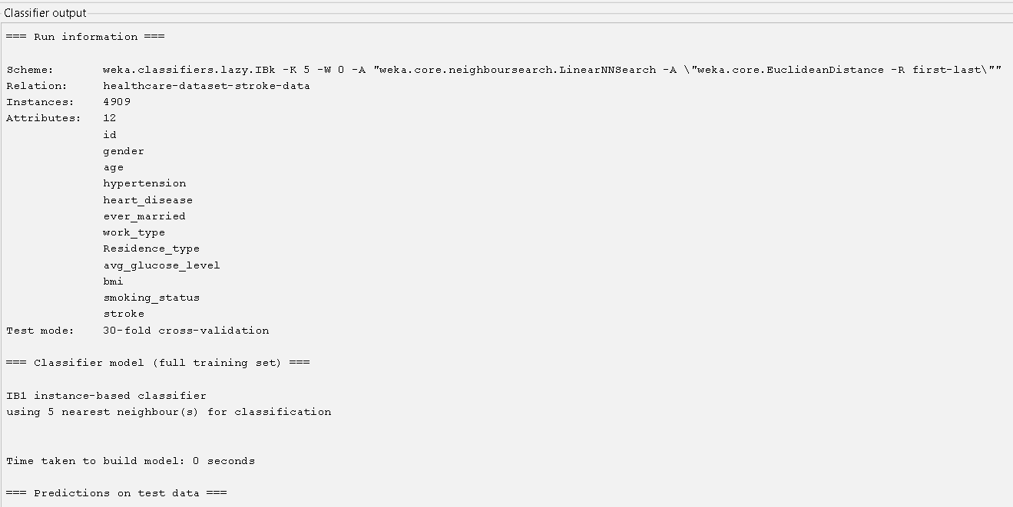

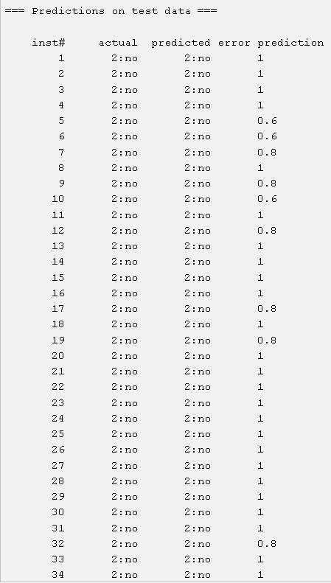

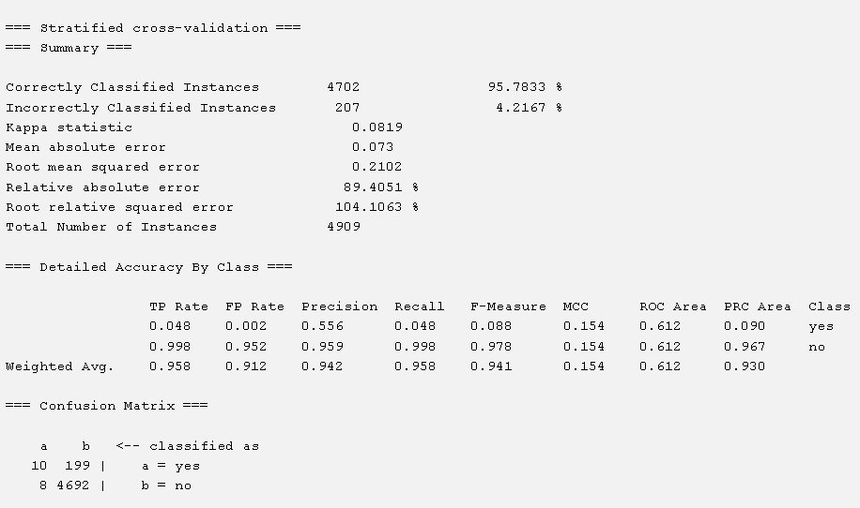

**Data Exchange and Integration:** Poor interoperability causes two types of problems [108]: trouble identifying patients and information blocking, in which healthcare providers impose arbitrary constraints on the transmission of clinical information and computerized health - related information. A fundamental hindrance to good healthcare delivery is the inadequacy of universally recognised user identities and info restriction mechanisms. Furthermore, compatibility is crucial, particularly during a pandemic like the corona virus. The pandemic's timing highlights the critical requirement for a stronger comprehensive information framework that may aid in improving physician communication and data flow to address concerns about public health. When visiting a doctor who isn't their main care provider, patients need easy access to their whole medical history. With enhanced health data flow, the possibility for remote monitoring and telemedicine consultations grows significantly. Patients may use this method to keep their physicians up to date on their health state [109].

**Blockchain-based solution frameworks for distributed data exchange:** The healthcare industry's interoperability issue might be overcome by using blockchain technology, which could substantially simplify the process of transmitting healthcare data. A patient's hash ID serves as a distinctive identify in a crypto currency healthcare blockchain. This hashing ensures that perhaps the ID is absolutely remarkable and conceals the identity of the user. Patients would be responsible for supplying the decryption key to their associated data blocks to their chosen healthcare practitioner (s). As a consequence, the patient may become the focal point of the ecosystem, increasing safety, privacy, and interoperability [110]. Access to full, up-to-date medical records would be very beneficial to both patients and physicians.

**The Current Situation with Medical Records:** Modern healthcare data recording and retrieval systems may exhibit the following qualities [98,99,100]: Building relationships between doctor and patient is critical. It consistently disregards the information. Making healthcare more difficult and time-consuming to get. Critical patient data is dispersed across several platforms. Many healthcare systems are unable to deliver required therapy to patients due to a lack of vital data availability. As a consequence, since so many individuals are ill-equipped to handle things smoothly, the management system suffers. It does not offer enough security or dependability for critical medical information. Most medical records are still retained on paper and stored in several places, adding to the healthcare industry's overall inefficiencies. They are ineffective for coordinating treatment, assessing quality, and decreasing medical mistakes [101]. Several sites gather healthcare data via digital data capture. It is critical to extract as much value from this healthcare data as possible while without adding undue complexity to current operations. The capacity to swiftly and economically capture and retain information, as well as securely communicate it across various applications and systems, is a critical challenge in the healthcare business [98]. Furthermore, information must be transferrable between systems and platforms must continuously interoperate [102].

**Services of IOT Healthcare Blockchain:**

A. Identification via Radio Frequency RFID technology in healthcare allows medical instruments to move around by employing passive RFID tags. Real-time location system (RTLS) enables the monitoring of labeled things in real time and contributes to the development of a network of devices connected that constantly track and report any changes in the position, circumstances, and amount of the marked objects. A survey is provided on the RFID application to body-centric systems, which gathers data on the user's living environment (temperature, humidity, and gases) [7]. [8] explains and proposes a thorough tracking presence span and successful HCMS using IoT and RFID chips. Using a combination of microcontrollers and sensors, this system verifies discoveries, monitors the patient's health, and extends the possibilities of the Internet of Things. A smart residence platform based on the iHome Health-IoT is proposed and developed, providing an accessible framework iMedBox for something like the incorporation of gadgets and services with improving accessibility and interoperability. Intelligent pharmaceutical packaging can interact thanks to rfid System and an Arduino Ethernet shield.

B. Working on the "Edge" of Computing Computing is a networking design that allows for the placement of both computational and storage capabilities within the radio access network (RAN), hence improving performance of the network and digital distribution to end users [10]. A Petri net-based RPN framework appropriate for EDs systems is provided, which integrates with bespoke cloud and edge computing. The concept applies RPN to a real-world situation in order to maximize important performance variables such as patient loss, resource scheduling rate, and vast majority of patients waiting time. Wireless body area networks (BANs) may be enhanced for the implementation of smart healthcare and suggested for efficient, private intelligent treatment with the use of mobile cloud services and computing [11]. Edge computing is highly helpful for instrumentation including such sensors in intensive care units which need immediate data processing and command execution, like complex systems that maintain physiologic homeostasis [57]. Closed loop surveillance devices such as hormone levels, breathing, cerebral activity, heart beats, and digestive functions need not take patience to really be published to the internet due to the sophistication of the sensors. In, five further edge computing use cases [58] for patient Monitoring are discussed, including regional care, user-generated health information, enhanced care experience, distribution network, and cost reductions.

C. [12] Semantics Annotations for data are provided in an IoT-based semantic interoperability model (IoT-SIM) to promote seamless integration across heterogeneous IoT devices in the healthcare domain. The resource description framework (RDF) seems to be a semantic Search framework that uses annotation to meaningfully interact patient data. SPARQL queries are used to extract information from such an RDF graph. To improve compatibility amongst smart phones, a web Information architecture is proposed [13]. That can provide seamless integration between many facilitating communication, the semantic gateway as a service (SGS) embedded with semantic Web provides connectivity among methods including such extensible messaging and presence protocol (XMPP), constrained application protocol (CoAP), and message queue telemetry transport (MQTT). The SEG 3.0 approach has benefits for integrating heterogeneous data from numerous smart phones and enhancing seamless integration in the IoT domain [14]. Compatibility protocols and guidelines are essential for minimal heterogeneous networks to reach a sufficient level of efficiency.

D. The Cloud Computing Model The integration of the cloud computing, the Internet of Things, as well as the modern healthcenter information system will allow actual wearable sensors to capture e-storage of all patient data captured by various sensing devices, including photos, documentation, and recordings. In healthcare, cloud services provide three basic services: Software as a Service (SaaS), Platform as a Service (PaaS), and Infrastructure as a Service (IaaS) [15]. The present state of virtualized healthcare regarding health information storage is discussed in this research [16], as well as an introduction of cloud technology in general. It is considered how a large database may be utilized for big data analysis and tendency detection [17]. The online management structure for Internet - of - things e-health which offers an effective, reliable, as well as smooth approach to supplying, executing, protecting, enforces laws, as well as anticipating cloud management is explained [18]. This technology dramatically enhances operating effectiveness while lowering health-care costs.

E. Massive Data Adoption of contemporary technology is important not just for ensuring that patients much significantly greater care, but also for the improved sustainability of medical systems. Volume, velocity, variety, veracity, and value are the five Vs that constitute big data. A digital storage system for medical emergencies is built using the number and variety of health records [19]. When in a crisis, IaaS and SaaS are employed to arrange and grant access heterogeneous physiological parameters to critical health providers. Table II summarizes the benefits and drawbacks of current IoT technology. To develop the public cloud, the suggested WBAN system [20] includes SaaS, PaaS, and IaaS services. This system creates a participant's account, controls who's had access to that data, and enables them to decide if they prefer regular or ongoing surveillance, but it misses the security measures required to ensure that now the participant's data is really secure and confidential. A controller system is designed to explain the relationship between a participant's emotional responses and physiological adaptations [21]. The system includes data analysis techniques for extracting critical information and removing extraneous information from the database, using techniques that stress the building of huge data sets about which deep learning may be used. Additional development, such as deep learning and cloud-based big data management, is being considered [29].

F. Grid Technology Grid computing is developing as a possible answer to e-most Health's technical issues, such as medication development. Grid computing outperforms conventional IT systems by a wide margin due to the enormous need for processing power and the volume of real-time data transmission. A wireless grids management structure is suggested as an important enabler technology for the next pervasive Internet - of - things smart healthcare [22]. Another paper [23] presents an introduction of distributed systems, analyzes prospective computer and network applications, and proposes a take the steps necessary that enhances the Corporate Desktop Guidance on the implementation to improve decision making in medical practices. A permanent of healthcare as well as bioinformatics studies was established in [24] Medi GRID. It facilitates scientists' location-independent collaboration by providing grid services on a controlled e-Science network, as well as access to a broad range of programs for genomics, scientific visualization, but also medical trials.

G. Reality Augmentation Vr (VR) creates an entirely new cosmos, whereas mixed reality (AR) allows us to incorporate the most useful metadata within our perception of the real life. Education is a clear use of augmented reality in the health field, as experts must learn a tremendous amount about physiology and physical function. Hamza-Lup et al. [25] created a dispersed medical experience model that use the AR concept to educate healthcare professionals coordination while doing endotracheal similar categories. A new adaptive synchronized algorithm (ASA) enables the collaboration ar / vr (AR) atmosphere's shared state preservation, boosting users' sense of being present. Introduces AR and evaluates existing medicinal uses [6]. AR not only allows health providers to examine and engage with three-dimensional representations of sufferers' body, but it also functions as a patient teaching instrument. Ultrasonic imaging [27] and optical diagnostics [28] are two further medical applications of augmented reality. In the preceding part, we examined IoT healthcare strategies and explored cutting-edge healthcare technology.

|  |  |  |  |
| --- | --- | --- | --- |
| Year | Technology | Contributions | Limitations |
| 2017 | Radio Frequency Identification (RFID)  [7],[8],[9] | ● Collect data on the user's living surroundings.  ● Monitor the health condition and boost the power of IOT.  ●Allows for pharmaceutical packing (iMedPack). | ●High costs, interference issues, and certain signal problems |
| 2018 | Edge Computing  [10],[11],[57],[58] | ● Calculate the average patient waiting time, length of stay (LOS), and resource consumption rate.  ●Use wireless body area networks. and increases the power of IOT.  ●Closed-loop processes keep the body in a state of equilibrium.  ●Rural medicine, enhanced patient experience, and cost reductions | ●Less scalable, lacks cloud awareness, and cannot do resource pooling |
| 2017 | Semantic  [12],[13],[14] | ●Provide data annotations.  ● Enable XMPP, CoAP, and MQTT protocol communication. less scalable security level  ●Provide Semantic Interoperability in 10T domain. | ●Reduce scalability and flexibility, high level processing, lack data confidentiality technical problem and privacy |
| 2017 | Cloud Computing  [15],[16],[17],[57],[18] | ●E Patient records are stored electronically.  ●Keep a vast database. Time spent waiting.  ● Enforce regulations and forecast cloud data mobility for IOT enabled e-health. | ● Relying on an internet connection, a lower degree of security, and a technological issue |
| 2016 | Big Data  [1],[20],[21],[29] | ● During an emergency, organize disparate physiological data.  ● The patient's data is completely protected. and personal.  ● Remove unnecessary data and extract crucial information. | ● Data quality, cyber security risk, compliance, and cost are all considerations. |
| 2012 | Computing on the Grid [22],[23],[24] | ● Drug development  ● Extends healthcare and private decision making.  ●Provide infrastructure for medical and bioinformatical research. | ●Lack of grid software and standards |
| 2018 | Augmented Reality  [25],[26],[27],[28] | ●Train medical practitioners’ hand-eye coordination.  ● Participants' sensation of presence is increased. technology, low performance level  ● Make infrastructure available for medical and bioinformatics research. | ● AR is expensive to deploy and develop, and it lacks security. |

**IoT Healthcare Blockchain Networks:**

A. Design of the IoThNet The structure of IoThNet refers to the placement of numerous components. It specifies how a composite computer network manages a high number of vital symptoms and sensor data via remote monitoring in common healthcare scenarios [13],[135]. The independent data were then processed and saved in a suitable database [22]. As indicated before, it may reply depending on the approach, allowing caregivers to observe patient circumstances from any location [15]. To keep health information streaming, IoThNet architecture gateways and access information need IP and a worldwide network for communications technology (GSM). iMedPack and iMedBox are recognized by various wireless designs as a combination of many detectors and connectors for smart healthcare. These components may be found in iMedPack and iMedBox [136-138]. The IoT healthcare infrastructure architecture unites clinical equipment with multiple IoT devices and is linked to the health-IoT cloud through healthcare gateways in order to evaluate and save the information recorded [139].

B. IoThNet Organization the IoThNet architectural concept outlined the methods and operating structure of the IoThNet's physical components [50]. Concerns concerning the competence of Iot personal computers, caretakers, wireless local area networks (WLAN), information in any manner, and encrypted connections remain in the architecture of IoThNet [132]. Various research efforts [132], [138], and [141] have demonstrated that IoThNet, biosensor, and worn data transfer using the 802.15.4 standard can be accomplished in IPv6 and 6LoWPAN [13] networks. Sensor network data contains authentication header standard interpretations (UDP) [13]. Routers are one of four different techniques to mobility [147]. DAG begins as well as needs to send data notifications in between these routers, soliciting routers, and sending DODAG information solicitation (DIS) messages to define the swiftest techniques of the network nodes itself to link various directed acyclic graph (DAG) and information object (DIO) having to wait for yet another feasible root node [142]. The IoThNet architecture includes three complex e-Health delivery services: 1) composition, 2) signalization, and 3) data transmission. IoThNet signalization protocols recognize the Quality of Service (QoS) technique and resource allocation since they offer heterogeneous service configuration. The next section describes the state of public cloud synthesis inside the shared data system, the platforms’ structure, and the IoThNet design [19].

C. IoThNet Platforms: The IoT healthcare networking technology platform is indeed the residential medical knowledge platform in the Internet of things.

It aids in categorizing distinct healthcare systems depending on how caretakers use different databases depending just on healthcare support layer [148]. provides a similar notion of data bases, encompassing smart object middleware as well as the business layer [83]. The approach, in particular, protects the interoperable and automation conceptual design foundation again for Iot environment [83]. It provides numerous individuals with varied senses as during collection of health information, enabling the Gateway to collaborate supporting control equipment. The automation and applications interactions developed through interaction normalization, healthcare information configurations [electronic medical records (EHR)], as well as security devices that safely relate inter - operability the with proposed framework entail cross - disciplinary enhancement [13] and are applied to regulate planning. The IoThNet system, automated handling technique (ADM), is utilized for restoration objectives, specifically specified restoration goals. Xu et al. [19] described IoThNet, as well as a supporting control scheme that utilizes three-layer cloud technology platforms is employed to capture ubiquitous user information. Several research have investigated their concerns about IoThNet platform difficulties. The architecture of the semantic platform is presented in.

|  |  |  |
| --- | --- | --- |
| **Blockchain Networks** | **Contributions** | **Limitations** |
| IOThNET Topology | Cloud computing, Heterogeneous Network,  Stored and analyzed independent data,  Observe the patient's condition,  Streaming of ultrasound network. | Inefficient healthcare service provider, Poor application design |
| IOThNET Architecture | 6LoWPAN data transfer based on IPv6, standard gateway Protocall stack, router addressing protocol | Low on application storage |
| IOThNET Platform | Human machine interface | Poor platform provider, Low skilled telecom operators, not enough healthcare means suppliers. |

**Blockchain Transaction and Access Management:** A safe approach should be performed in order to manage and evaluate the enormous amount of information that the patient has provided. Moreover, when many users are connected to the information being created, a secret component user access scheme be developed, which is another issue addressed by the Blockchain Network. The proposed architecture calls for the usage of two essential blockchain networks: the Personal Health Care Blockchain (PHC) and the External Record Management (ERM) Blockchain. For most cases, the patient is the individual who manages the personalized health blockchain because it identifies and collects data via wearables. Whenever a physician obtains access to data, he or she may use it to help understand the condition of the patient and recommend the best prescription for them. In additional to just being kept inside the blockchain network, data collected by wearables is saved inside an outside cloud server managed by the blockchain network. When a patient sees a doctor, data is created that must be maintained, which is accomplished via the use of an external record management blockchain. The ERM Blockchain often tracks pharmaceutical expenses, medical test results, prescriptions, imaging data, and data generated by healthcare institutions. The data is added to the chain in line with the "Proof of Stake" process, which has been authorized by all blockchain stakeholders. Given that the Healthcare Center and the Doctor own the majority of the ownership in the ERM Blockchain project, they control the bulk of the equity. In this situation, all patient data will be encrypted before being stored in the cloud using strong blockchain technology. To read or access the data, everyone needs a decryption key, in this instance the patient's fingerprint. After decrypting the data, the patient may transmit it to whoever he wants. Insurance companies are also permitted to use the Blockchain network to authenticate patient data in the event that a patient makes a claim.

**Proposed Procedure:** The method for transmitting the image, voice, and text is to encrypt and send the file. Using the Salsa 20, Proof of Stake, Cryptocurrency algorithm for security, the image, voice, and text can be encrypted and sent through the block in order to connect to the previous block. Consequently, the information/data will be stored in both the healthcare facility and the blockchain. To detect abnormalities inside the participant's healthcare information behaviour, the proposed system integrates the Internet of Things (IoT), Blockchain, and Deep Learning. Blockchain technology is being used by a worldwide computer system to manage a database that holds patient information including such testing results, diagnostic devices, medication, utilization acquired subsequent application, and so forth. This information is administered through its own system rather than a centralized network (peer-to-peer network). [103]. As a consequence, the blockchain may be compared to a library that contains all books, including a patient's health data, prescription data, medical imaging data, and biological testing data. Regardless of the method used to gather the data, it is combined, and the whole medical act allows for the creation of a complete picture of the patient. The solution presented is simply a system that utilizes an Internet of Things module to monitor and extract data generated by the person's gadgets. The Blockchain system demonstrated here is ideal for maintaining and storing patient data in the form of numerous transactions, as well as providing network access to diverse stakeholders. Moreover, the Blockchain architecture is being utilized to help the medical research community by preserving the pseudo-anonymity of the patient's name and giving approved and reliable information for even more reflect all available information. The machine learning model detects anomalies and predicts specific scenarios which may take place in the future by data analysis using the parameters provided by physicians again for basic diagnosis of the ailments which the sufferers are encountering. Before data can be recorded in the virtual catalog of transactions, it must first be validated by a miner, who will also collect the data (if everything is in order). The processes of writing, encrypting, and inserting data are all classified as "mining." Each user's computer does difficult mathematical computations that result in the creation of new blocks, and they are compensated financially for their efforts. No frames are included in the block of nodes in the lack of nodes agreement (miners). This technique, though, does not offer access to extremely specialised processing via visualisation only if a user has indeed been given authorisation. To verify his permission, the person will use his thumbprint. If the computer has verified the data, it could be analyzed safely. To data encryption in a digital catalog, complicated math procedures are used. As soon as the computers are linked to the blockchain software through the Internet, removing or editing data once it has been stored in a transaction will be extremely difficult (almost impossible). It should not be assumed that using the blockchain as a web infrastructure is equivalent to operating it. [104], [105]. Hospitals would no longer need to preserve archives if all of the patient's data, including recipes, biological tests, and treatment results, were kept on the blockchainInside an crisis, it could enable again for collection of the entire participant's medical information inside one area, as well as extremely quick findings. Even if not, everyone has access to the blockchain, the system may still function. The patient should decide who has access to his or her data in that block. This demonstrates that it is only a theoretical idea aimed at improving the transparency and courtesy of the healthcare system. Figure 3: [106], [107].

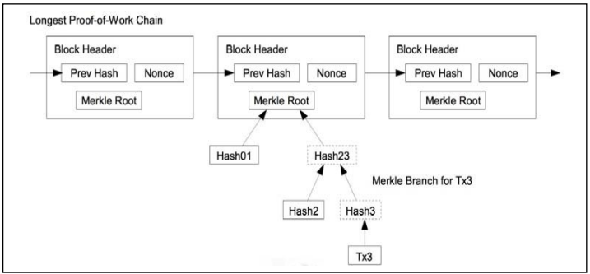

Fig:5: The information circuit between the blocks

**Market Overview:**

In 2018, hospitals and medical facilities dominated the Internet of Things (IoT) in the health technology industry. Growing use of IoT-enabled medical equipment by healthcare professionals to enhance care delivery effectiveness as well as provide patient-centric care delivery services represents one of the main reasons boosting the market's rise.

Bangladesh's healthcare business is expanding, with hospital, pharmacies, diagnostic centers, clinical studies, outsourced, videoconferencing, plus medicinal gadgets and technology all on the rise. The healthcare industry has nearly tripled in size over the past eight years, rising at an annual average growth rate (CAGR) of 10.3% from USD 3.92 billion in 2010 to USD 6.76 billion in 2018. Collegiate hospitals and diagnostics facilities, both important parts of the healthcare delivery system, have witnessed tremendous increase in the private industry. The General Authority of Health Care services had recognized 255 public hospitals, 5,054 commercial hospital and clinics, and 9,529 diagnostic facilities as of the end of 2019. (DGHS). There have been 143,394 medical beds available across the country by the end of 2019. This includes 54,660 public hospital beds and 91,537 private hospital beds. As medical and pharmaceutical expenses continue to climb, the healthcare sector is looking for ways to lower these costs while also increasing the quality of treatment offered. As a consequence of the significant technological problems, concerns, and possibilities it confronts, the healthcare business is fast developing in a number of ways. To begin, pharmaceutical firms, governments, and highly skilled medical experts no longer collaborate. Tech titans are making inroads into the healthcare business with the objective of enhancing patient access to treatment and provider quality at a reduced cost. Large corporations are investing a growing share of their huge R&D spending to improving people's health. Second, traditional medical treatment focuses on symptom relief rather than core cause resolution. COVID-19 has the potential to accelerate the transition to continuous healthcare, in which choices are increasingly backed up by layered data. Apple, Google, Amazon, and others sell wearables that use sensors to continuously monitor vital indicators including such temperatures, pulse rate, respiration sounds, heart rate variability and step count. Seven days a week, twenty-four hours a day. In the future, food routines, sleeping routines, as well as other activity data may be analyzed with the data and health evaluations gathered by these gadgets. These companies' software was designed to improve patients' lives in whatever conceivable way by tracking their behaviors and habits and delivering preventative counsel based on the findings of digital biomedical research. In the following COVID-driven initiative, Apple and Google will release a full Bluetooth-based opt-in contact tracking system. Individual mobility monitoring, precise interactions between tracked persons, health data accurate interactions between tracked individuals, and whole contact tracing utilizing publicly accessible mass consumer data are all proposed implementations [90]. Any technological solution to improving healthcare must be mindful of the specific obstacles that the healthcare business has in comparison to other economic sectors, as well as the real demands of customers, patients, providers, and regulators Many businesses are looking at blockchain technology to see if it may assist them speed up processes, conserve money, enhance clinical outcomes, enforce standards, and create good use of health records [91]. The blockchain-based healthcare system is becoming more popular. More than two-thirds of the over 200 health sciences leaders polled by IBM from 18 countries think blockchain would help them reduce wasteful bureaucratic procedures and obsolete systems that stymie innovation and adaption [92]. Anthem, the ranked as the second insurance company, said in 2019 that it will use blockchain technology to keep the medical information of 40 million individuals [93]. The possibilities and applications of blockchain technology in healthcare and life sciences are summarized in Table 1 [94, 93, 95-97]. After that, we'll examine at how blockchain technology can help with healthcare information management difficulties.

The Internet of Things (IoT) in health industry was estimated to be worth 46.44 billion in 2020 and is expected to be worth 89.6 billion by 2026, growing at an 11.6% CAGR between 2021 and 2026. The rising use of healthcare systems, the rise of big data in healthcare, the increase of gadget reliability and connection, and the expanding prevalence of linked medical equipment are driving the IoT industry.

**The Research's Limitations:** There exists a dearth of consensus studies on the advantages and disadvantages of integrating blockchain technology in the healthcare sector. This essay lends weight to an area where consultants often make strong claims. The primary flaw in this study is that the findings were based on the use of the phrase "blockchain in healthcare," rather than on healthcare-related technology.

**Conclusion:**

The incorporation of IoT technology into medical systems is transforming the company's future. We examined and summarized their benefits and drawbacks. Then we spoke about the communication networks, designs, and technologies that are presently being used for IoT in healthcare. Then, we went through all of the primary application protocols, delivering services protocols, and infrastructural protocols that are being researched and deployed in IoT common standards. A substantial element of our study also included a thorough examination of the security of the IoT healthcare system. In this part, we covered the overall security needs of an IoT system, as well as the usual challenges involved with satisfying these criteria. In addition, we presented a Blockchain-based IoT system architecture that is capable of resolving modern security issues. Next, we spoke about the useability and applications where IoT may make a huge difference in the healthcare business.

**REFERENCES:**

[1] Siyal, A. A., Junejo, A. Z., Zawish, M., Ahmed, K., Khalil, A., & Soursou, G. (2019). Applications of

blockchain technology in medicine and healthcare: Challenges and future perspectives. Cryptography, 3(1),

3.

[2] Dwivedi, A. D., Srivastava, G., Dhar, S., & Singh, R. (2019). Decentralized privacy-preserving healthcare

blockchain for IoT. Sensors, 19(2), 326.

[3] Dubovitskaya, A., Xu, Z., Ryu, S., Schumacher, M., & Wang, F. (2017). Secure and trustable electronic

medical records shared using blockchain. In AMIA annual symposium proceedings (Vol. 2017, p. 650).

American Medical Informatics Association.

[4] Zheng, Z., et al. An overview of blockchain technology: Architecture, consensus, and future trends. in Big Data

(BigData Congress), 2017 IEEE International Congress on. 2017. IEEE. DOI: 10.1109/BigDataCongress.2017.85.

[5] Zhao, H., et al. Lightweight Backup and Efficient Recovery Scheme for Health Blockchain Keys. in Autonomous

Decentralized System (ISADS), 2017 IEEE 13th International Symposium on. 2017. IEEE. DOI:

10.1109/ISADS.2017.22.

[6] J. M. Blythe and S. D. Johnson, “The consumer security index for

IoT: A protocol for developing an index to improve consumer decision

making and to incentivize greater security provision in IoT devices,” in

Proc. Living Internet Things Cybersecurity IoT (IET), London, U.K.,

2018, p. 7.

[7] S. Amendola, R. Lodato, S. Manzari, C. Occhiuzzi, and G. Marrocco, “RFID technology for IoT-based personal healthcare in smart spaces,” IEEE Internet Things J., vol. 1, no. 2, pp. 144–152, Apr. 2014.

[8] S. F. Khan, “Health care monitoring system in Internet of Things (IoT)

by using RFID,” in Proc. 6th Int. Conf. Ind. Technol. Manag. (ICITM),

2017, pp. 198–204.

[9] G. Abinaya and K. P. Sampoornam “An efficient healthcare system in IoT platform using RFID system,” Int. J. Adv. Res. Electron. Commun. Eng., vol. 5, no. 2, pp. 421–424, 2017.

[10] S. Oueida, Y. Kotb, M. Aloqaily, Y. Jararweh, and T. Baker, “An edge

computing based smart healthcare framework for resource management,” Sensors Multidiscipl. Digit. Publ. Inst., vol. 18, no. 12, p. 4307,

2018.

[11] S. Otoum, M. Ahmed, and H. T. Mouftah, “Sensor medium access control (SMAC)-based epilepsy patients monitoring system,” in Proc. IEEE 28th Can. Conf. Elect. Comput. Eng. (CCECE), Halifax, NS, Canada, 2015, pp. 1109–1114.

[12] S. Jabbar, F. Ullah, S. Khalid, M. Khan, and K. Han, “Semantic interoperability in heterogeneous IoT infrastructure for healthcare,” Wireless Commun. Mobile Comput., vol. 2017, Mar. 2017, Art. no. 9731806.

[13] P. Desai, A. Sheth, and P. Anantharam, “Semantic gateway as a service architecture for IoT interoperability,” in Proc. IEEE Int. Conf. Mobile Serv., New York, NY, USA, 2015, pp. 313–319.

[14] A. Yrard and M. Serrano, “Connected smart cities: Interoperability with SEG 3.0 for the Internet of Things,” in Proc. 30th Int. Conf. Adv. Inf. Netw. Appl. Workshops (WAINA), Crans-Montana, Switzerland, 2016, pp. 796–802.

[15] S. B. Baker, W. Xiang, and I. Atkinson, “Internet of Things for smart healthcare: Technologies, challenges, and opportunities,” IEEE Access, vol. 5, pp. 26521–26544, 2017.

[16] N. Sultan, “Making use of cloud computing for healthcare provision: Opportunities and challenges,” IEEE Access, vol. 34, pp. 177–184, 2014.

[17] L. A. Tawalbeh, R. Mehmood, E. Benkhlifa, and H. Song, “Mobile

cloud computing model and big data analysis for healthcare applications,” IEEE Access, vol. 4, pp. 6171–6180, 2016.

[18] R. Vargheese and Y. Viniotis, “Influencing data availability in IoT enabled cloud based e-health in a 30 day readmission context,” in Proc. 10th IEEE Int. Conf. Collab. Comput. Netw. Appl. Worksharing, Miami, FL, USA, 2014, pp. 475–480.

[19] B. Xu, L. D. Xu, H. Cai, C. Xie, J. Hu, and F. Bu, “Ubiquitous data accessing method in IoT-based information system for emergency medical services,” IEEE Trans. Ind. Informat., vol. 10, no. 2, pp. 1578–1586, May 2014.

[20] S. Ghanavati, J. Abawajy, and D. Izadi, “An alternative sensor cloud architecture for vital signs monitoring,” in Proc. Int. Joint Conf. Neural Netw. (IJCNN), Vancouver, BC, Canada, 2016, pp. 2827–2833.

[21] K. Lin, F. Xia, W. Wang, D. Tian, and J. Song, “System design for big data application in emotion-aware healthcare,” IEEE Access, vol. 4, pp. 6901–6909, 2016.

[22] H. Viswanathan, E. K. Lee, and D. Pompili, “Mobile grid computing for data- and patient-centric ubiquitous healthcare,” in Proc. 1st IEEE Workshop Enabling Technol. Smartphone Internet Things (ETSIoT), Seoul, South Korea, 2012, pp. 36–41.

[23] C. Brust, “Grid computing in a healthcare environment: A Framework for enterprise design and implementation,” in Proc. Annu. Conf. Midwest United States Assoc. Inf. Syst. (MWAIS), 2009, p. 33.

[24] A. Weisbecker, J. Falkner, and O. Rienhoff, “MediGRID—Grid computing for medicine and life sciences,” in Grid Computing. Boston, MA, USA: Springer, 2009, pp. 57–65.

[25] F. G. Hamza-Lup, J. P. Rolland and C. Hughes, “A distributed augmented reality system for medical training and simulation,” 2018. [Online]. Available: arXiv:1811.12815.

[26] H.-G. Ha and J. Hong, “Augmented reality in medicine,” Hanyang

Med. Rev., vol. 36, no. 4, pp. 242–247, 2016.

[27] A. State et al., “Observing a volume rendered fetus within a pregnant patient,” in Proc. Vis., Washington, DC, USA, 1994, pp. 364–368.

[28] Y. Argotti, L. Davis, V. Outters, and J. P. Rolland, “Dynamic superimposition of synthetic objects on rigid and simple-deformable real objects,” Comput. Graph., vol. 26, no. 6, pp. 919–930, 2002.

[29] P. K. Sahoo, S. K. Mohapatra, and S.-L. Wu, “Analyzing healthcare big data with prediction for future health condition,” IEEE Access, vol. 4, pp. 9786–9799, 2016.

[30] S. S. Al-Majeed, I. S. Al-Mejibli, and J. Karam, “Home telehealth by Internet of Things (IoT),” in Proc. IEEE 28th Can. Conf. Elect. Comput. Eng. (CCECE), Halifax, NS, Canada, 2015, pp. 609–613.

[31] K. Pallavi and K. Tripti “Secure health monitoring of soldiers with

tracking system using IoT: A survey,” Int. J. Trend Sci. Res. Develop.,

vol. 3, no. 4, pp. 693–696, May/Jun. 2019.

[32] A. J. Jara, M. A. Zamora, and A. F. Skarmeta, “Drug identification and interaction checker based on IoT to minimize adverse drug reactions and improve drug compliance,” Pers. Ubiquitous Comput., vol. 18, no. 1, pp. 5–17, 2014.

[33] M. Srinivas, P. Durgaprasadarao, and V. N. P. Raj, “Intelligent medicine

box for medication management using IoT,” in Proc. 2nd Int. Conf.

Inventive Syst. Control (ICISC), Coimbatore, India, 2018, pp. 32–34.

[34] B. Prajapati, S. M. Parikh, and J. Patel, “An IoT base model to monitor real time effect of drug,” in Proc. 3rd Int. Conf. Internet Things Connected Technol. (ICIoTCT), 2018, pp. 26–27.

[35] P. Sundaravadivel, K. Kesavan, L. Kesavan, S. P. Mohanty, and E. Kougianos, “Smart-Log: A deep-learning based automated nutrition monitoring system in the IoT,” IEEE Trans. Consum. Electron., vol. 64, no. 3, pp. 390–398, Aug. 2018.

[36] E. Mendi, O. Ozyavuz, E. Pekesen, and C. Bayrak, “Food intake monitoring system for mobile devices,” in Proc. 5th IEEE Int. Workshop Adv. Sens. Interfaces (IWASI), vol. 64. Bari, Italy, 2013, pp. 31–33

[37] R. S. H. Istepanian, S. Hu, N. Y. Philip, and A. Sungoor, “The potential of Internet of m-health things ’m-IoT’ for non-invasive glucose level sensing,” in Proc. Annu. Int. Conf. IEEE Eng. Med. Biol. Soc., 2016, pp. 5264–5266.

[38] Z. Lijun, “Multi-parameter medical acquisition detector based on Internet of Things,” Chinese Patent CN202 960 774U, 2013.

[39] U. U. Deshpande and M. A. Kulkarni, “IoT based real time ECG monitoring system using cypress wiced,” Int. J. Adv. Res. Elect. Electron. Instrum. Eng., vol. 6, no. 2, 2014. [83] L. Yang, Y. Ge, W. Li, W. Rao, and W. Shen, “A home mobile healthcare system for wheelchair users,” in Proc. IEEE 18th Int. Conf. Comput. Supported Cooperative Work Design (CSCWD), Hsinchu, Taiwan, 2014, pp. 609–614.

[40] P. Castillejo, J.-F. Martinez, J. Rodriguez-Molina, and A. Cuerva “Integration of wearable devices in a wireless sensor network for an ehealth application,” IEEE Wireless Commun., vol. 20, no. 4, pp. 38–49, Aug. 2013.

[41] E. Agu et al., “The smartphone as a medical device: Assessing enablers, benefits and challenges,” in Proc. IEEE Int. Workshop Internet Things Netw. Control (IoT-NC), New Orleans, LA, USA, 2013, pp. 48–52.

[42] M.-L. Liu, L. Tao, and Z. Yan, “Internet of Things-based electrocardiogram monitoring system,” Chinese Patent CN102 764 118A, 2012.

[43] T. J. Xin, B. Min, and J. Jie, “Carry-on blood pressure/pulse rate/blood oxygen monitoring location intelligent terminal based on Internet of Things,” Chinese Patent CN202 875 315U, 2013.

[44] J. Puustjärvi and L. Puustjärvi, “Automating remote monitoring and information therapy: An opportunity to practice telemedicine in developing countries,” in Proc. IST Africa Conf., 2011, pp. 1–9.

[45] L. M. R. Tarouco et al., “Internet of Things in healthcare: Interoperatibility and security issues,” in Proc. IEEE Int. Conf. Commun. (ICC), Ottawa, ON, Canada, 2012, pp. 6121–6125. [46] A. Dohr, R. Modre-Opsrian, M. Drobics, D. Hayn, and G. Schreier, “The Internet of Things for ambient assisted living,” in Proc. 7th Int. Conf. Inf. Technol. New Gener., Las Vegas, NV, USA, 2010, pp. 804–809.

[47] E. C. Larson, T. Lee, S. Liu, M. Rosenfeld, and S. N. Patel, “Accurate and privacy preserving cough sensing using a low-cost microphone,” in Proc. 13th Int. Conf. Ubiquitous Comput., 2011, pp. 375–384.

[48] H. A. Khattak, M. Ruta, and E. E. Di Sciascio, “CoAP-based healthcare sensor networks: A survey,” in Proc. 11th Int. Bhurban Conf. Appl. Sci. Technol. (IBCAST), Islamabad, Pakistan, Jan. 2014, pp. 499–503.

[49] E. C. Larson, M. Goel, G. Boriello, S. Heltshe, M. Rosenfeld, and S. N. Patel, “SpiroSmart: Using a microphone to measure lung function on a mobile phone,” in Proc. ACM Conf. Ubiquitous Comput., 2012, pp. 280–289.

[50] Z. Guangnan and L. Penghui, “IoT (Internet of Things) control system facing rehabilitation training of hemiplegic patients,” Chinese Patent CN202 587 045U, 2012.

[51] Y. J. Fan, Y. H. Yin, L. D. Xu, Y. Zeng, and F. Wu, “IoT-based smart rehabilitation system,” IEEE Trans. Ind. Informat., vol. 10, no. 2, pp. 1568–1577, May 2014.

[52] B. Tan and O. Tian, “Short paper: Using BSN for tele-health application in upper limb rehabilitation,” in Proc. IEEE World Forum Internet Things (WF-IoT), Seoul, South Korea, 2014, pp. 169–170.

[53] S. Liang, Y. Zilong, S. Hai, and M. Trinidad, “Childhood autism language training system and Internet-of-Things-based centralized training center,” Chinese Patent CN102 184 661A, 2011.

[54] K. U. Sreekanth and K. P. Nitha, “A study on health care in Internet of Things,” Int. J. Recent Innovat. Trends Comput. Commun., vol. 4, pp. 44–47, Jan. 2016.

[55] ED wait times in the news - 3 keys to lower them for patients. Accessed: Apr. 26, 2020. [Online]. Available: http://www.healthcarebusinesstech.com/ed-wait-times-analytics/

[56] [Online]. Available: http://www.healthcarebusinesstech.com/iothospital-future

[57] Will Edge Computing Transform Healthcare? Accessed: Apr. 26, 2020. [Online]. Available: https://healthtechmagazine.net/article/2019/08/ will-edge-computing-transform-healthcare.

[58] (2019). 5 Use Cases to Know for Edge Computing and Healthcare. [Online]. Available: https://www.vxchnge.com/blog/edge-computinguse-cases-healthcare?

[59] (2018). How IoT Is Enabling the Telemedicine of Tomorrow. [Online]. Available: https://www.iotforall.com/how-iot-enables-tomorrowstelemedicine/

[60] (2017). Medication Management for Patients Through IoT-Enabled Smart Pillboxes. [Online]. Available: https://iiot-world.com/smarthealthcare/medication-management-for-patients-through-iot-enabledsmart-pillboxes/

[61] S. Ojas, S. Akshay, S. Rohitkumar, and A. Trupti “IoT based telemedicine system,” in Proc. IEEE Int. Conf. Power Control Signals Instrum. Eng. (ICPCSI), Chennai, India, 2017, pp. 2840–2842.

[62] S. Saminathan and K. Geetha, “Real-time health care monitoring

system using IoT,” Int. J. Eng. Technol., vol. 7, pp. 484–488, Apr. 2018.

[63] A. D. Dwivedi, G. Srivastava, S. Dhar, and R. Singh, “A decentralized privacy-preserving healthcare blockchain for IoT,” Sensors

Multidiscipl. Digit. Publ. Inst., vol. 19, no. 2, p. 326, 2019.

[64] D. Sharma and R. C. Tripathi, “Performance of Internet of Things

(IoT) based healthcare secure services and its importance: Issue and

challenges,” in Proc. Int. Conf. Innovat. Comput. Commun. (ICICC),

2020, p. 4.

[65] K. T. Kadhim, A. M. Alsahlany, S. M. Wadi, and H. T. Kadhum, “An

Overview of patient’s health status monitoring system based on Internet

of Things (IoT),” Wireless Pers. Commun., vol. 114, pp. 2235–2262,

May 2020.

[66] T. Lemlouma, S. Laborie, P. Roose, A. Rachedi, and K. Abdelaziz,

A Study of Mobility Support in Wearable Health Monitoring Systems:

Design Framework. Cleveland, OH, USA: CRC Press, 2014.

[67] A. Boulemtafes, A. Rachedi, and N. Badache, “A study of mobility

support in wearable health monitoring systems: Design framework,”

in Proc. IEEE/ACS 12th Int. Conf. Comput. Syst. Appl. (AICCSA),

Marrakech, Morocco, 2015, pp. 1–8.

[68] T. Lemlouma, A. Rachedi, M. A. Chalouf, and S. A. Chellouche,

“A new model for NGN pervasive e-Health services,” in Proc. 1st

Int. Symp. Future Inf. Commun. Technol. Ubiquitous HealthCare

(Ubi-HealthTech), Jinhua, China, 2013, pp. 1–5.

[69] D. He, S. Zeadally, N. Kumar, and J. H. Lee, “Anonymous authentication for wireless body area networks with provable security,” IEEE

Syst. J., vol. 11, no. 4, pp. 2590–2601, Dec. 2017.

[70] H. K. Ngankam et al., “An IoT architecture of microservices for ambient assisted living environments to promote aging in smart cities,”

in Proc. Int. Conf. Smart Homes Health Telematics, vol. 11, 2019,

pp. 154–167.

[71] D. Minoli, K. Sohraby, and B. Occhiogrosso, “IoT security (IoTSec)

mechanisms for e-Health and ambient assisted living applications,” in

Proc. IEEE/ACM Int. Conf. Connected Health Appl. Syst. Eng. Technol.

(CHASE), pp. 13–18, Philadelphia, PA, USA, 2017, pp. 13–18.

[72] Kamel Boulos MN, Wilson JT, Clauson KA. Geospatial blockchain: promises, challenges, and scenarios in health and healthcare. Int J Health Geogr. 2018; 17:25.

[73] Chen Y, Ding S, Xu Z, Zheng H, Yang S. Blockchain-based medical records secure storage and medical service framework. J Med Syst. 2018;43:5.

[74] Kuo T-T, Kim H-E, Ohno-Machado L. Blockchain distributed ledger technologies for biomedical and health care applications. J Am Med Inform Assoc. 2017;24:1211–20.

[75] Mamoshina P, Ojomoko L, Yanovich Y, Ostrovski A, Botezatu A, Prikhodko P, et al. Converging blockchain and next-generation artificial intelligence technologies to decentralize and accelerate biomedical research and healthcare. Oncotarget. 2017;9:5665–90.

[76] Mettler M. Blockchain technology in healthcare: The revolution starts here. In: 2016 IEEE 18th International Conference on e-Health Networking, Applications and Services (Healthcom) 2016;1-3. IEEE. https://ieeexplore.ieee. org/document/7749510.

[77] Furlonger D, Kandaswamy R. Hype Cycle for Blockchain Business. 2018. [https://www.gartner.com/doc/3884146/hype-cycle-blockchain-business. Accessed 3 Dec 2018](https://www.gartner.com/doc/3884146/hype-cycle-blockchain-business.%20Accessed%203%20Dec%202018).

[78] Kuo T-T, Kim H-E, Ohno-Machado L. Blockchain distributed ledger technologies for biomedical and health care applications. J Am Med Inform Assoc. 2017;24:1211–20.

[79] Angraal S, Krumholz HM, Schulz WL. Blockchain technology: applications in health care. Circulation: Cardiovascular Quality and Outcomes. 2017;10(9): e003800.

[80] Mettler M. Blockchain technology in healthcare: The revolution starts here. In: 2016 IEEE 18th International Conference on e-Health Networking, Applications and Services (Healthcom) 2016;1-3. IEEE. https://ieeexplore.ieee. org/document/7749510.

[81] Kuo T-T, Zavaleta Rojas H, Ohno-Machado L. Comparison of blockchain platforms: a systematic review and healthcare examples. JAMIA. 2019. <https://doi.org/10.1093/jamia/ocy185>.

[82] Ivan D. Moving Toward a Blockchain-based Method for the Secure Storage of Patient Records. In: ONC/NIST Use of Blockchain for Healthcare and Research Workshop. Gaithersburg, MD; 2016. https://www.healthit.gov/sites/ default/files/9-16-drew_ivan_20160804_blockchain_for_healthcare_final.pdf. Accessed 18 Feb 2019.

[83] Azaria A, Ekblaw A, Vieira T, Lippman A. MedRec: Using Blockchain for Medical Data Access and Permission Management. International Conference on Open and Big Data (OBD). Vienna: IEEE; 2016. p. 25–30.

[84] Kuo T-T, Ohno-Machado L. ModelChain: decentralized privacy-preserving healthcare predictive modeling framework on private blockchain networks. arXiv. 2018;arXiv:1802.01746.

[85] Kuo T-T, Gabriel RA, Ohno-Machado L. Fair compute loads enabled by blockchain: sharing models by alternating client and server roles. JAMIA. 2019. <https://doi.org/10.1093/jamia/ocy180>.

[86] Sweeney L. Simple demographics often identify people uniquely. Health (San Francisco). 2000;671:1–34.

[87] Munro D. Data Breaches in Healthcare Totaled Over 112 Million Records in 2015. 2015. https://www.forbes.com/sites/danmunro/2015/12/31/data- breaches-in-healthcare-total-over-112-million-records-in-2015/ #15b74ef7b07f. Accessed 18 Feb 2019.

[88] Wang S, Jiang X, Wu Y, Cui L, Cheng S, Ohno-Machado L. Expectation propagation logistic regression (explorer): distributed privacy-preserving online model learning. J Biomed Inform. 2013;46(3):480–96.

[89] Wu Y, Jiang X, Kim J, Ohno-Machado L. Grid Binary LOgistic REgression (GLORE): building shared models without sharing data. JAMIA. 2012;19(5):758–64.

[90] Sainz F. Apple and Google partner on COVID-19 contact tracing technology. Apple News. 2020 [cited 2020 Apr 17]. Available from: https://www.apple.com/ newsroom/2020/04/apple-and-google-partner-oncovid-19-contact-tracing-technology/.

[91] Mackey TK, Kuo T, Gummadi B, et al. ‘Fit-for-purpose?’ - challenges and opportunities for applications of blockchain technology in the future of healthcare. BMC Med. 2019 Mar 27;17(1):68.

[92] IBM Institute for Business Value. Team medicine: how life sciences can win with blockchain. IBM Corporation. 2018 [cited 2018 Mar 12]. Available from: https://public.dhe.ibm.com/common/ssi/ecm/ 03/en/03013903usen/team-medicine.pdf.

[93] Rosenbaum L. Anthem will use blockchain to secure medical data for its 40 million members in three years. Forbes. 2019 Dec 12. [cited 2020 Mar 17]. Available from: https://www.forbes.com/sites/ leahrosenbaum/2019/12/12/anthem-says-its-40- million-members-will-be-using-blockchain-tosecure-patient-data-in-three-years/#305bc9be6837.

[94] Kuo TT, Kim HE, Ohno-Machado L. Blockchain distributed ledger technologies for biomedical and health care applications. J Am Med Inform Assoc 2017 Nov;24(6):1211–1220.

[95] Hoy MB. An introduction to the blockchain and its implications for libraries and medicine. Med Ref Serv Q. 2017;36(3):273–279.

[96] Yaeger K, Martini M, Rasouli J, et al. Emerging blockchain technology solutions for modern healthcare infrastructure. J Sci Innov Med. 2019;9(9):2–7.

[97] Leon K. How is blockchain revolutionizing healthcare? The Startup. 2018 Oct 23, [cited 2020 Jan 17]. Available from: https://medium.com/swlh/how-isblockchain-revolutionizing-healthcare-d971d351528f.

[98] Pirtle C, Ehrenfeld JM. Blockchain for healthcare: the next generation of medical records? J Med Syst. 2018 Aug;42(9). Article 172.

[99] Paranjape K, Parker M, Houlding D, et al. Implementation considerations for blockchain in healthcare institutions. Blockchain in Healthcare Today. Volume 2; 2019 Jul.

[100] Singh N. Blockchain for healthcare: use cases and applications. 101 Blockchains. 2019 Nov 21 [cited 2020 Jan 18]. Available from: https://101blockchains. com/blockchain-for-healthcare/.

[101] Hillestad R, Bigelow J, Bower A, et al. Can electronic medical record systems transform health care? potential health benefits, savings, and costs. Health Aff. 2019;24(5):1103–1117.

[102] Yaeger K, Martini M, Rasouli J, et al. Emerging blockchain technology solutions for modern healthcare infrastructure. J Sci Innov Med. 2019;9(9):2–7.

[103] Daniel Drescher, “Blockchain Basics: A Non-Technical Introduction in 25 Steps”, ISBN 13: 978-1484226032, 2016.

[104] Tiana Laurence, “Blockchain For Dummies (For Dummies (Computers))”, ISBN 978-1-119-36559-4.

[105] Jeff Reed, “Blockchain, Smart Contracts, Investing in Ethereum, FinTech”, Kindle Edition.

[106] Gary Mitnick, “Blockchain: Learn Blockchain Technology FAST!Everything You Need to Know About Blockchain in 1 Hr!”, Kindle Edition.

[107] https://blog.ethereum.org/2017/01/19/update-integratingzcash-ethereum.

[108] Gordon WJ, Catalini C. Blockchain technology for healthcare: facilitating the transition to patient-driven interoperability. Comput Struct Biotechnol J. 2018;16:224–230.

[109] Postelnicu L. How the world of health and tech is looking at the coronavirus outbreak. 2020 Mar 11, Mobihealthnews. [cited 2020 Mar 22]. Available from: https://www.mobihealthnews.com/news/ europe/how-world-health-and-tech-looking-coronavirus-outbreak.

[110] Paranjape K, Parker M, Houlding D, et al. Implementation considerations for blockchain in healthcare institutions. Blockchain in Healthcare Today. Volume 2; 2019 Jul.

[111] [Diabetes Prediction | Kaggle](https://www.kaggle.com/code/mvanshika/diabetes-prediction/data)

[112] [Cancer Patients Data | Kaggle](https://www.kaggle.com/datasets/rishidamarla/cancer-patients-data)

[113] [Stroke Prediction Dataset | Kaggle](https://www.kaggle.com/datasets/fedesoriano/stroke-prediction-dataset)